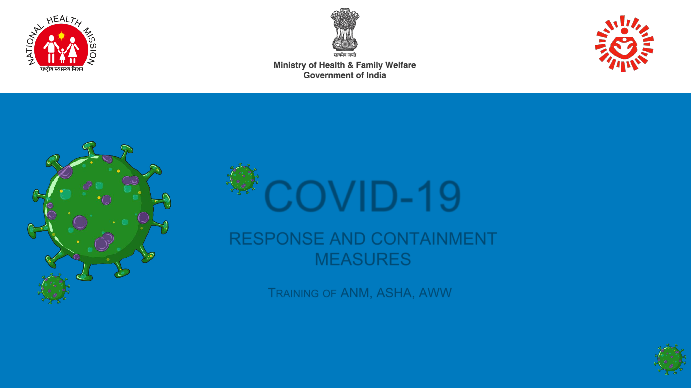

COVID-19

RESPONSE AND CONTAINMENT

MEASURES

TRAINING OF ANM, ASHA, AWW

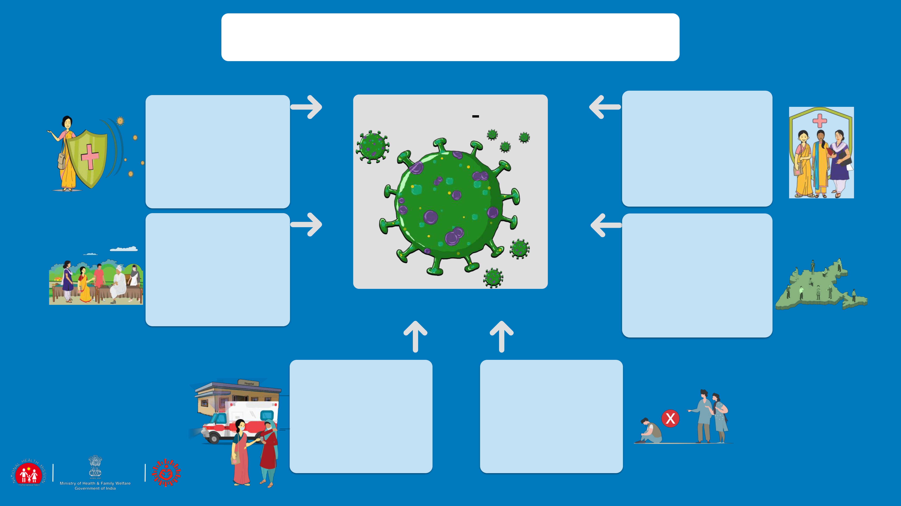

WHAT ARE WE GOING TO LEARN?

|  |  |  |  |  |
| --- | --- | --- | --- | --- |
| ROLE OF THE FLW | 1 | COVID-19 | 6 PERSONAL SAFETY |  |
|  | Frontline workers will work |  |
|  |  |  |  |
| This session talks about | |  | to reach out the message |  |
|  | to thousands of directly or |  |
| the role that each of the |  |  |  |
|  |  | indirectly affected |  |
| frontline worker plays |  |  |  |
|  |  | community members. |  |
| and what she needs to |  |  | However they also need to |  |
| understand about |  |  | take care of their own |  |
| COVID-19 |  |  | personal safety |  |
|  |  |  |  |
| INFORMATION TO THE | 2 |  | 5 SUPPORTIVE PUBLIC |  |
|  |  | HEALTH SERVICES: |  |
|  |  |  |  |

|  |  |  |
| --- | --- | --- |
| COMMUNITY | COMMUNITY & HH |  |
| This section talks about the |  |
| What is the role that |  |
| information and knowledge |  |
| community networks play in |  |
| that the FLW will give to the |  |
| addressing COVID in the |  |
| community on Handwashing, |  |
| community, what are the |  |
| Cough hygiene, Social |  |
| services required: home care , |  |
| distancing and HRG |  |
| home quarantine in urban |  |
|  |  |
|  | and rural areas |  |

|  |  |  |
| --- | --- | --- |
| COMMUNITY | 3 | 4 |
| SURVEILLANCE |  | STIGMA & DISCRMINATION |
| Session discusses the |  | This session deals with the |
| contact tracing protocol, how | | myths and misconceptions |
| to identify the contact, what | | around Coronavirus and many |
| are the guidelines for |  | fears that result in stigmatising |
| supporting people who are | | behaviours at various level. |
| suspected, symptomatic or | | What is the role of the FLW |
| asymptomatic cases |  | and what can she do |

 02



SESSION 1

Communication for Response and Containment Measures

 03



ROLE OF ANM, ASHA & AWW

HEALTH - ANM

UNDER GUIDANCE OF DSO/MO

* Provide information

1. Preventive and control measures including social distancing during the phases of the COVID

outbreak

* 1. Addressing myths and misconceptions;
* Support DSO on
  + 1. Contact tracing as per SOPs
    2. Link public health (home quarantine, home care, and supportive services for HRG and probable cases) in urban and rural areas &
    3. Psychosocial care and discrimination stigma and discrimination.
* Reporting and feedback across different phases of COVID-19 pandemic (no cases, imported/sporadic cases, clusters and community wide transmission)
* Personal Safety and Precautions
* Supervision of effective usage COVID-19 IEC materials

HEALTH-ASHA, CHV(IN URBAN AREAS) AND ICDS –AWW, UNDER GUIDANCE OF ASHA FACILITATOR & CDPO

* Community awareness through inter-personal communication
  1. Uptake of preventive and control measures including social distancing
  2. Addressing myths and misconceptions;
* Support ANM/Supervisor in house to house surveillance including
  + 1. Identification of HRG and probable cases
       1. Ensure uptake of medical services in urban and rural areas and
       2. Psychosocial care, stigma and discrimination
* Reporting and feedback across different phases of COVID-19 pandemic (no cases, imported/sporadic cases, clusters and community wide transmission)
* Personal Safety and Precautions
* Use of COVID 19 IEC materials

 04

LET US UNDERSTAND

ABOUT COVID-19

COVID-19 IS

CORONAVIRUS DISEASE-2019

IT IS CAUSED BY A

CORONAVIRUS

NAMED AS SARS-CoV-2

WHAT ARE THE

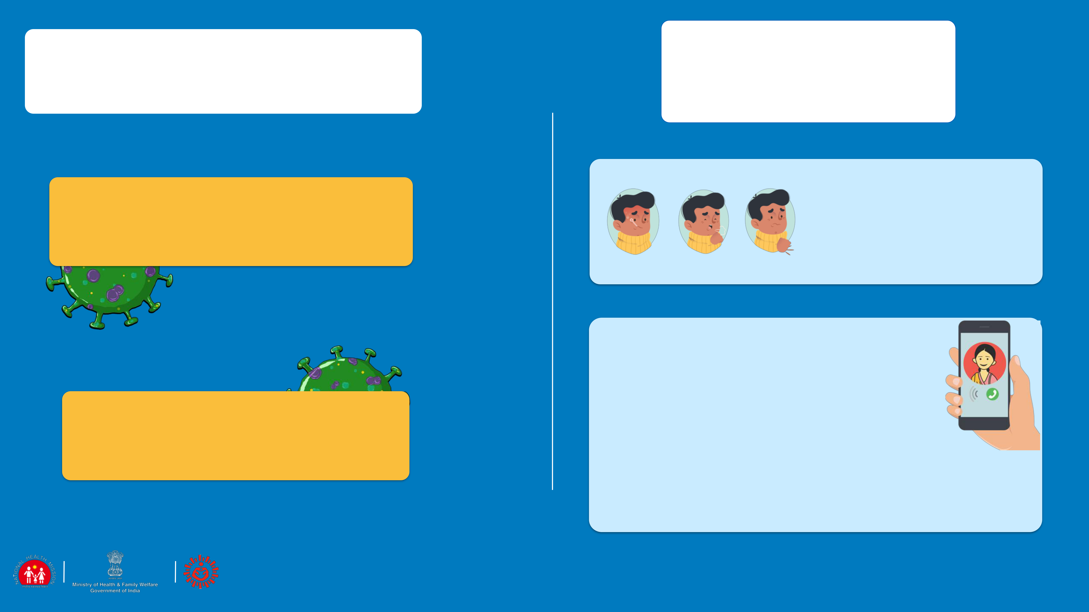

COMMON SYMPTOMS

OF COVID-19

THE SYMPTOMS OF COVID-19 ARE FEVER, COUGH, AND DIFFICULTY IN BREATHING

IF YOU HAVE THESE AND YOU ARE A CONTACT OF

A LABORATORY CONFIRMED POSITIVE CASE

IMMEDIATELY CALL THE STATE HELPLINE NUMBER OR MINISTRY OF HEALTH & FAMILY WELFARE, GOVERNMENT OF INDIA 24X7 HELPLINE

011-2397 8046, 1075 OR YOUR ASHA/ANM.

 05

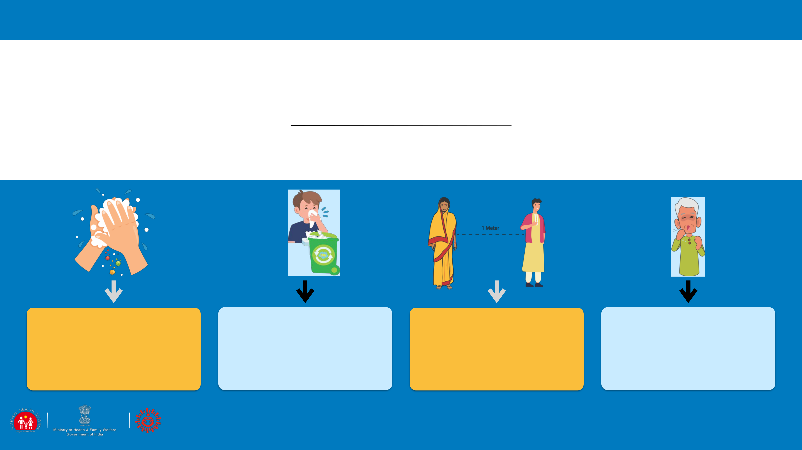

SESSION 2

PREVENTION: SAFE PRACTICES IN THE COMMUNITY

|  |  |  |  |
| --- | --- | --- | --- |
| HAND | RESPIRATORY | SOCIAL | HIGH RISK |
| HYGIENE | HYGIENE | DISTANCING | GROUP |
|  |  |  |  |

 06

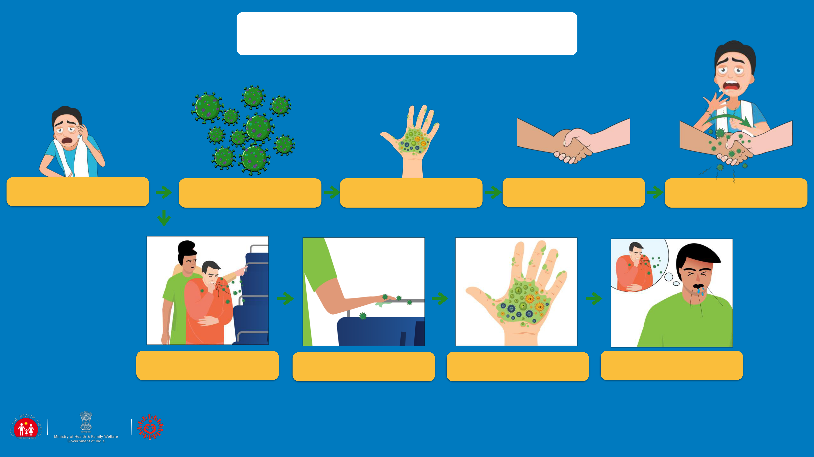

MODES OF TRANSMISSION

|  |  |  |  |  |  |
| --- | --- | --- | --- | --- | --- |
| SNEEZE/ COUGH | INFECTED DROPLETS | INFECTED DROPLETS | AND WHEN TOUCH | VIRUS |  |
| BY INFECTED PERSON | GET ON YOUR HAND | ANY SURFACE OR PERSON | TRANSFERRED!! |  |
|  |  |

|  |  |  |  |  |
| --- | --- | --- | --- | --- |
| SNEEZE/ COUGH | INFECTED DROPLETS | INFECTED DROPLETS | VIRUS |  |
| BY INFECTED PERSON | GET ON YOUR HAND | TRANSFERRED!! |  |
|  |  |

 07

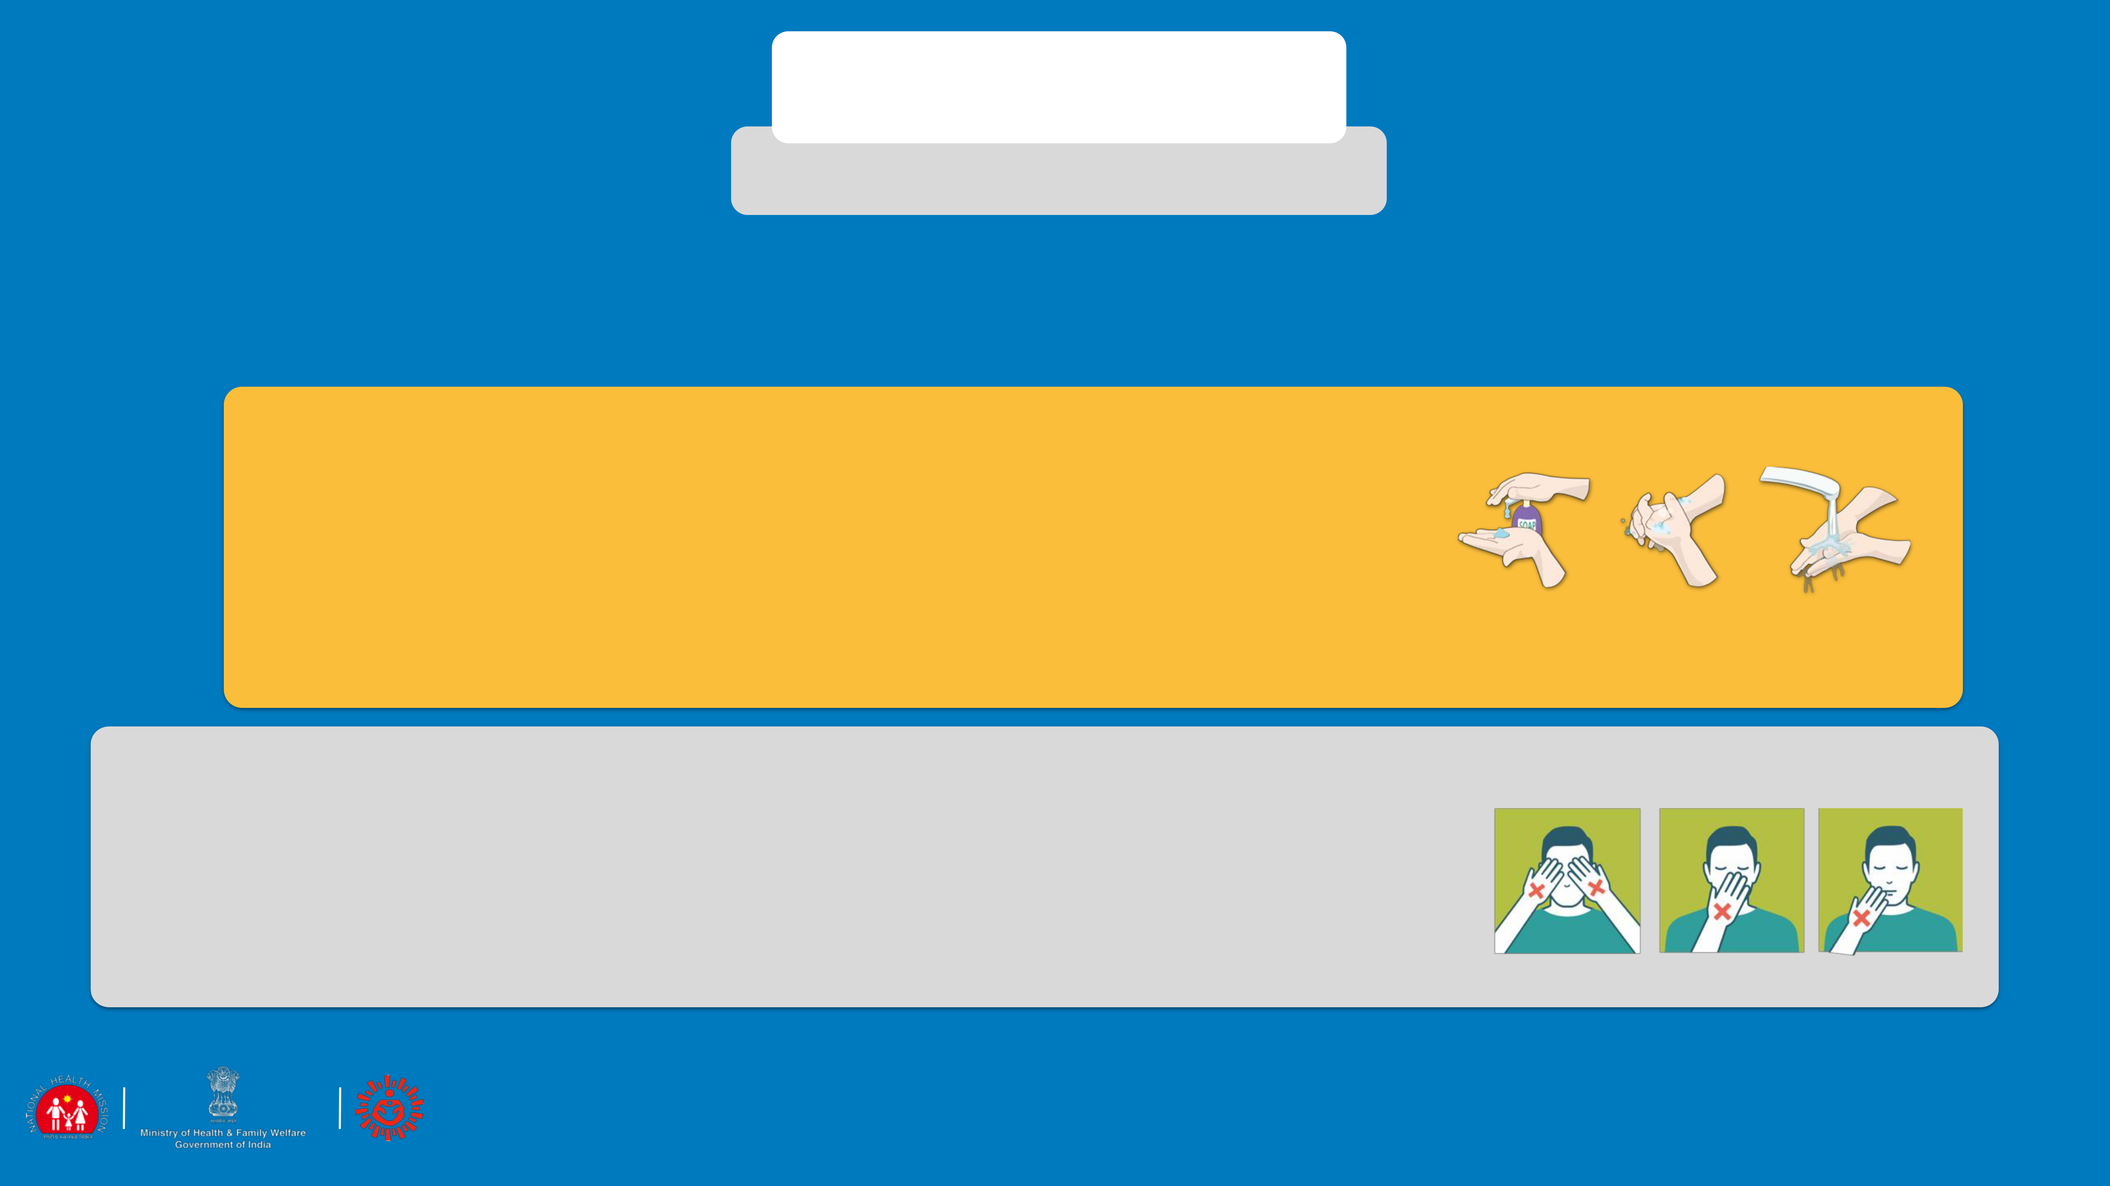

HAND HYGIENE

PREVENTION - WHAT TO DO?

Hand hygiene is a way of cleaning one's hands that substantially reduces potential pathogens (harmful germs) on the hands. Hand hygiene procedures include hand washing with soap and water for at least 40 secs or use of 70% alcohol-based hand rubs

|  |  |  |
| --- | --- | --- |
|  | ▪ WASH YOUR HANDS OFTEN WITH SOAP AND WATER FOR 40 |  |
|  | SECONDS ESPECIALLY AFTER YOU HAVE BEEN IN A PUBLIC |  |
| DO | PLACE, OR AFTER BLOWING YOUR NOSE, COUGHING, OR |  |
| SNEEZING. |  |
| ▪ USE A HAND SANITISER (AT LEAST 70% ALCOHOL BASED) IF |  |
| SOAP AND WATER NOT AVAILABLE COVER ALL SURFACES |  |
|  | OF YOUR HANDS AND RUB THEM TOGETHER UNTIL THEY |  |
|  | FEEL DRY. |  |

|  |  |  |
| --- | --- | --- |
|  | ▪ TOUCH YOUR EYES, NOSE, AND MOUTH WITH |  |
| DO NOT | UNWASHED HANDS. |  |
| ▪ TOUCH SURFACES LIKE DOOR KNOBS AND |  |
| DOOR BELLS, ELEVATOR BUTTONS, HANDRAILS, |  |
| SUPPORT HANDLES, CHAIR BACKS, ATM |  |
|  | SURFACES, MOBILES, JEEP HANDLES ETC |  |

 08

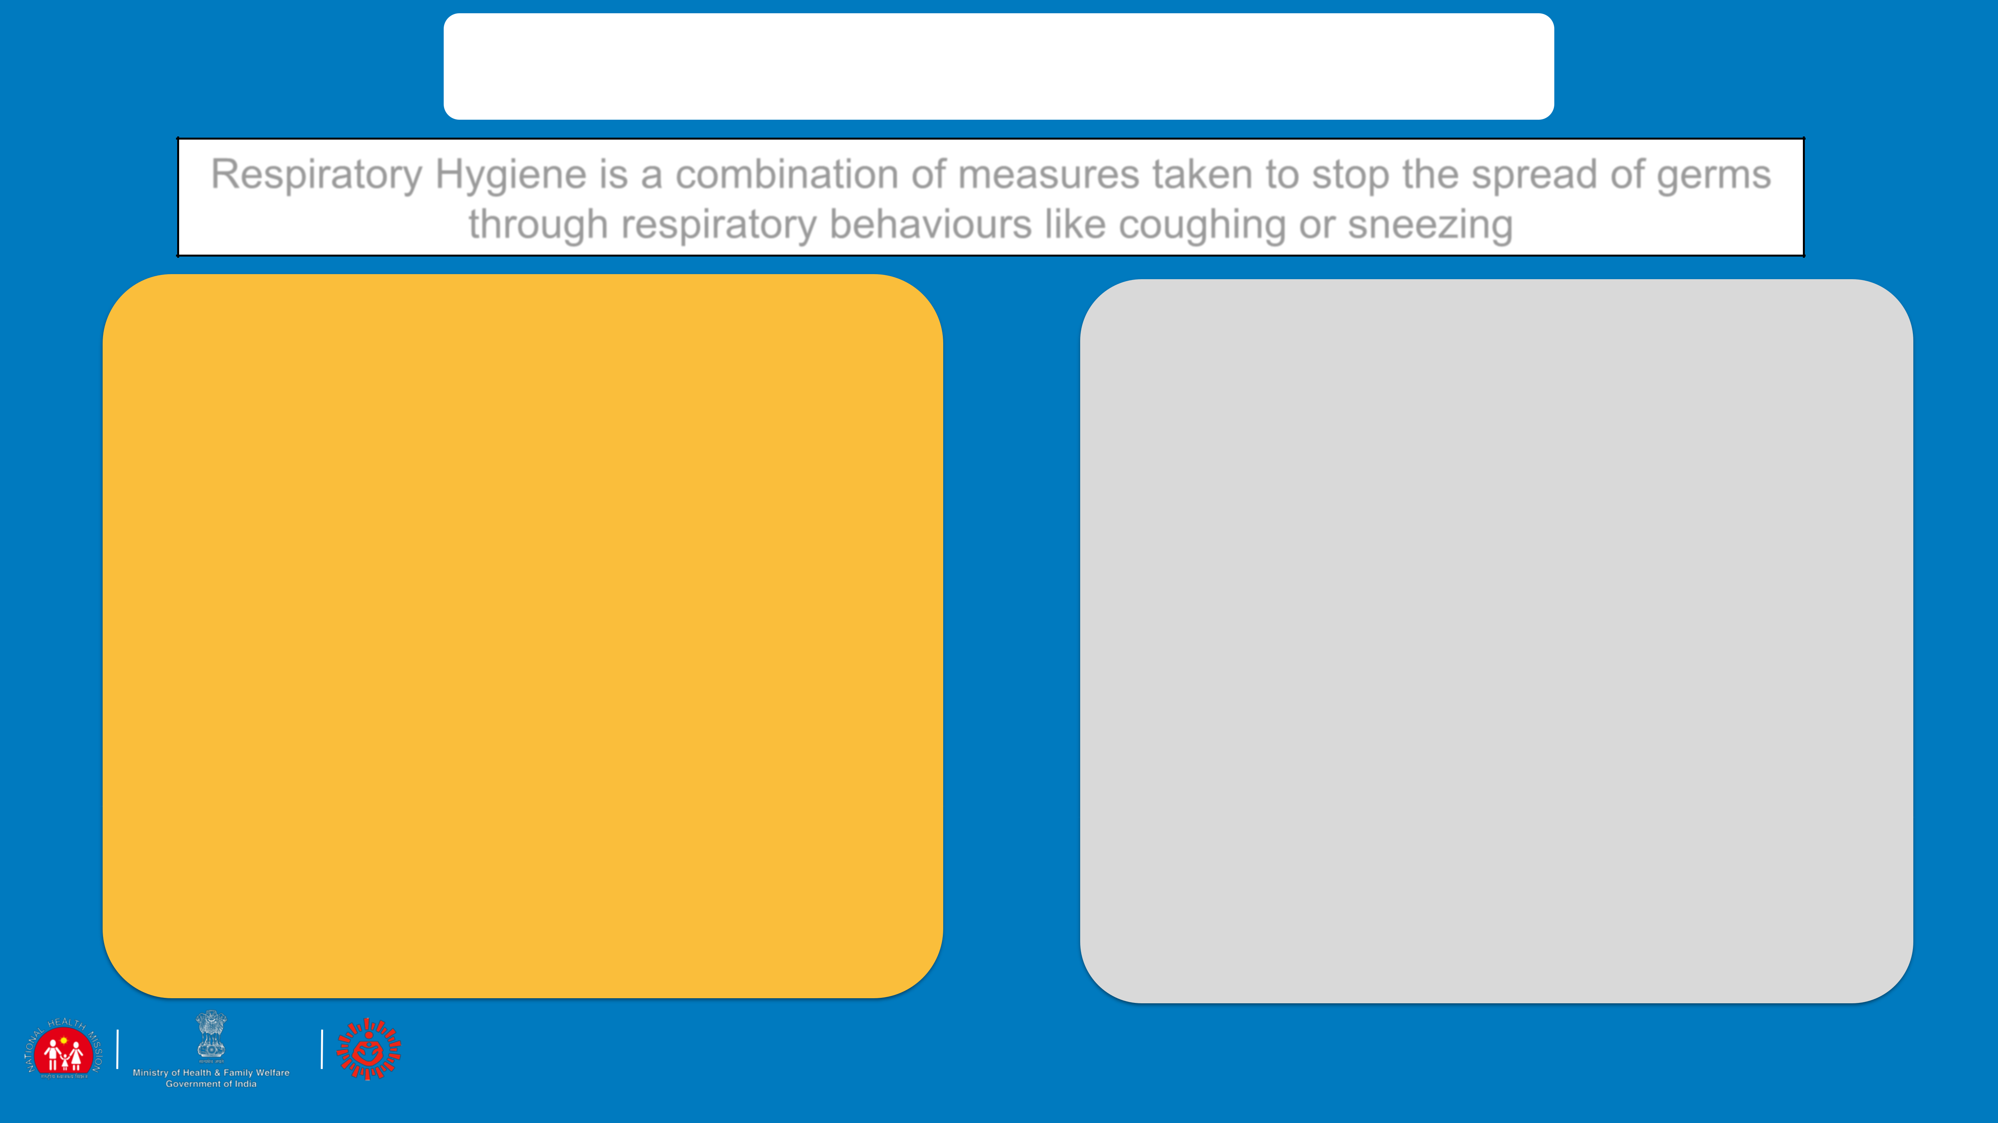

PREVENTION: RESPIRATORY HYGIENE

Respiratory Hygiene is a combination of measures taken to stop the spread of germs

through respiratory behaviours like coughing or sneezing

DO

* DO USE a handkerchief or a tissue to cover your face while coughing or sneezing
* DO THROW the used tissue immediately into a closed dustbin
* DO COVER your sneeze into your bent upper arm in case you are not carrying a tissue or a kerchief.
* DO WASH hands immediately after you have covered your sneeze or cough

DO NOT

* DO NOT use other ways of covering your face like the pallu of the sari of the chunni or the gamcha
* DO NOT spit in the open, always use a spittoon or wash basin for spitting

 09

CASE STUDY

Smita has gone out to buy vegetables. She has a sore throat and is often coughing without covering her face. You are in the shop when she comes and suddenly she has a fit of cough. Everyone instantly moves away from her and the shopkeeper says angrily “Don’t come into my shop if you are coughing.”

QUESTION 1: IF YOU WERE THERE AS A CUSTOMER; WHAT WOULD YOU HAVE DONE?

QUESTION 2: IF YOU WERE THE SHOPKEEPER, WHAT WOULD YOU HAVE DONE?

QUESTION 3: AS A HEALTH WORKER WHAT WOULD YOU ADVISE/COUNSEL?

ANSWERS

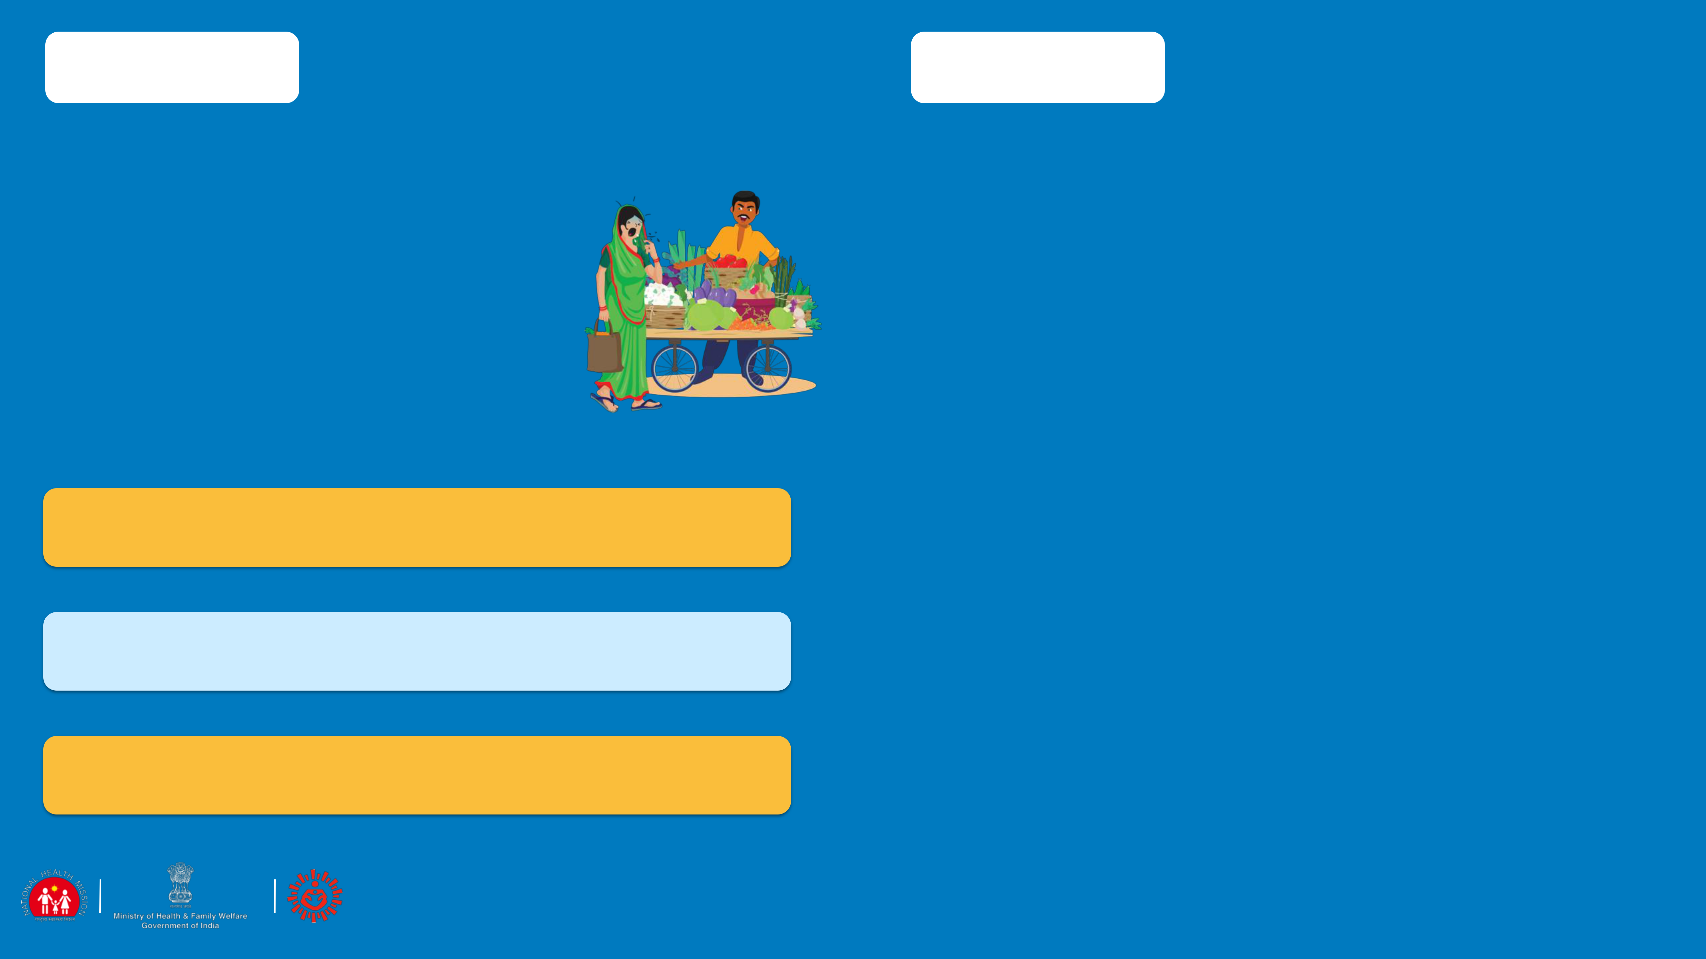

* It is good for people to move away and keep a distance. However, as a fellow customer anyone could give a polite advice to follow the correct respiratory hygiene.
* It is wrong for the shopkeeper to have shouted at Smita. This is stigmatising behaviour. Though everyone is scared, being rude is not helpful. It will just keep people away from reporting a problem if they feel discriminated against. The shopkeeper can also keep his shop infection free by wiping the counters with a

disinfectant regularly.

As a health worker my job will be:

* Counsel Smita that she must cover her face with a handkerchief when coughing. Suggest her to get medication at the PHC
* Counsel the shopkeeper that anyone can have a cough and it need not be coronavirus infection. However anyone can have the infection and therefore he can help by keeping a box of tissues and hand sanitizer on the counter or keep a washing station for people to wash their hand.
* Counsel people on respiratory hygiene

 10

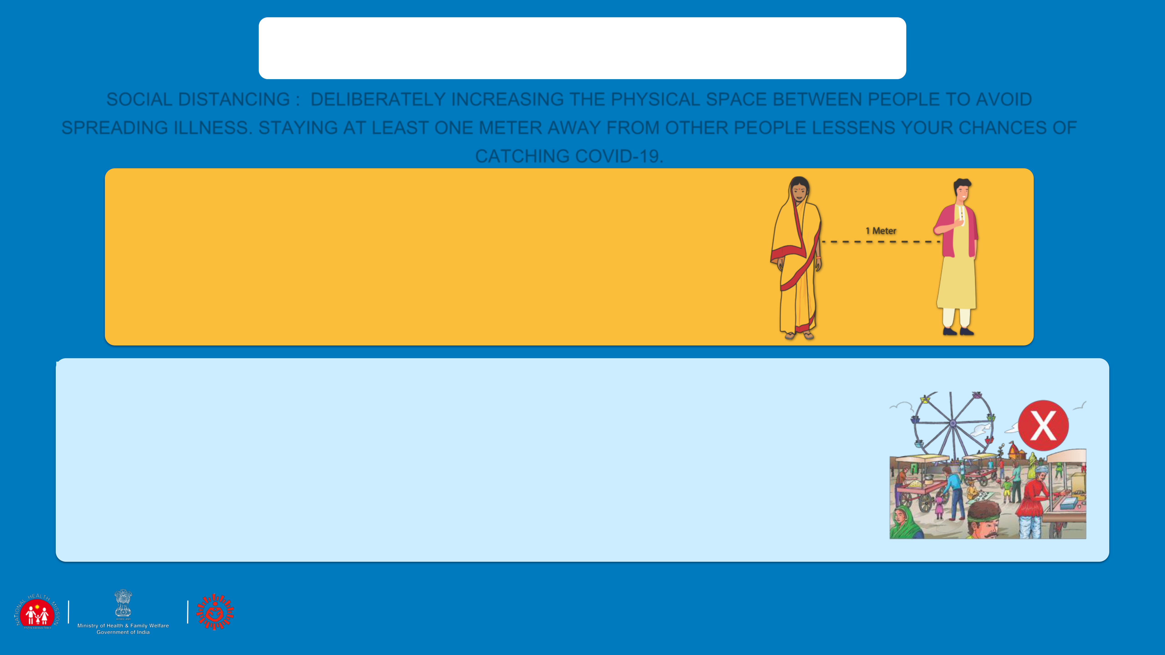

PREVENTION: SOCIAL DISTANCING

SOCIAL DISTANCING : DELIBERATELY INCREASING THE PHYSICAL SPACE BETWEEN PEOPLE TO AVOID

SPREADING ILLNESS. STAYING AT LEAST ONE METER AWAY FROM OTHER PEOPLE LESSENS YOUR CHANCES OF

|  |  |  |
| --- | --- | --- |
|  | CATCHING COVID-19. |  |
|  | • STAY AT HOME UNLESS ABSOLUTELY |  |
| DO | NECESSARY |  |
| • KEEP A DISTANCE OF AT LEAST ONE METER |  |
| BETWEEN YOURSELF AND ANOTHER |  |
|  | PERSON |  |

DO

NOT

* + DO NOT HOLD EVENTS WHERE PEOPLE HAVE TO GATHER (EVEN IF IT IS A CORNER MEETING WITH THREE OR FOUR FRIENDS, OR AN EVENING CHAT ON THE CHAUPAL)
* DO NOT GO TO CROWDED PLACES LIKE MARKETS, SHOPPING, MELAS, PARTIES
* DO NOT USE PUBLIC TRANSPORT

 11

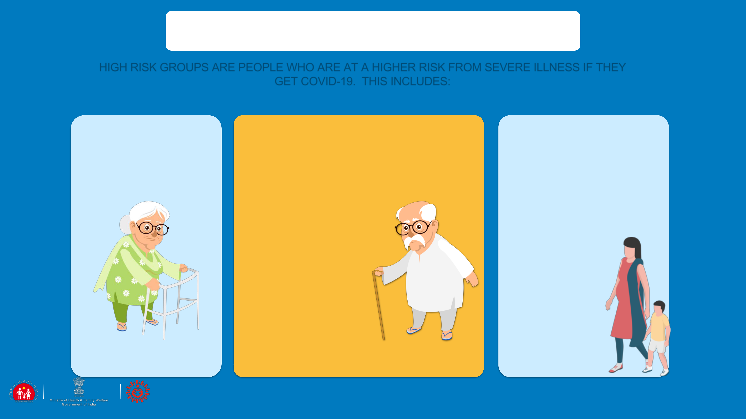

PREVENTION: HIGH RISK GROUP

HIGH RISK GROUPS ARE PEOPLE WHO ARE AT A HIGHER RISK FROM SEVERE ILLNESS IF THEY

GET COVID-19. THIS INCLUDES:

|  |  |  |  |
| --- | --- | --- | --- |
| OLDER ADULTS | PEOPLE WHO HAVE UNDERLYING | PREGNANT |  |
| MEDICAL CONDITIONS LIKE: |  |
| WOMEN |  |
|  |  |
|  | ▪ HEART DISEASE |  |
|  | (AS WE DO NOT |  |
|  | ▪ DIABETES | KNOW THE |  |
|  | ▪ LUNG DISEASE | IMPACT OF THE |  |
|  | DISEASE ON |  |
|  | ▪ KIDNEY DISEASE |  |
|  | PREGNANCY AS |  |
|  | ▪ ON CANCER |  |
|  | OF YET, IT IS |  |
|  | MEDICATION | BETTER TO TAKE |  |
|  |  | CARE) |  |

 12

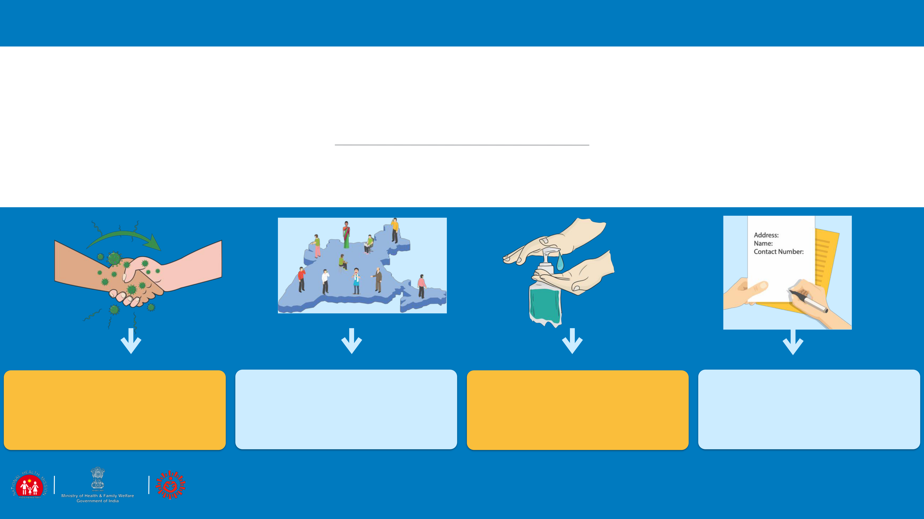

SESSION 3

COMMUNITY SURVEILLANCE

TYPES OF

CONTACTS

COMMUNITY

SURVEILLANCE SoP

ADVISORY COMMUNICATION

 13



DEFINITIONS – SUSPECT/PROBABLE INFECTED PERSON

A person with acute respiratory illness (fever and at least one sign/symptom of respiratory disease (eg. Cough, shortness of breath) AND

A history of travel to or residence in a country/area or territory reporting local transmission of COVID-19 disease during the 14 days prior to symptom onset OR

A person with any acute respiratory illness AND having being in contact with a confirmed COVID-19 case in the last 14 days prior to onset of symptoms OR

A person with severe acute respiratory infection {fever and at least one sign/symptom of respiratory disease (eg., Cough, shortness of breath)} AND requiring hospitalisation AND with no other etiology that fully explains the clinical presentation OR

A case for whom testing for COVID-19 is inconclusive.

DEFINITIONS - WHO IS A CONTACT

A CONTACT IS A PERSON WHO IS INVOLVED IN ANY OF THE FOLLOWING:

* PROVIDING DIRECT CARE WITHOUT PROPER PERSONAL PROTECTIVE EQUIPMENT (PPE) FOR COVID-19 PATIENTS
* STAYING IN THE SAME CLOSE ENVIRONMENT OF A COVID-19 PATIENT (INCLUDING WORKPLACE, CLASSROOM, HOUSEHOLD, GATHERINGS).
* TRAVELING TOGETHER IN CLOSE PROXIMITY (LESS THAN 1 M) WITH A SYMPTOMATIC PERSON WHO LATER TESTED POSITIVE FOR COVID-19.

 14



TYPES OF CONTACTS

HIGH RISK

* TOUCHED BODY FLUIDS OF THE PATIENT (RESPIRATORY TRACT SECRETIONS, BLOOD, VOMIT, SALIVA, URINE, FEACES)
* HAD DIRECT PHYSICAL CONTACT WITH THE BODY OF THE PATIENT, SHOOK HANDS, HUGGED OR TOOK CARE OF.
* TOUCHED OR CLEANED THE LINEN, CLOTHES, OR DISHES OF THE PATIENT.
* LIVED IN THE SAME HOUSEHOLD AS THE PATIENT.
* ANYONE IN CLOSE PROXIMITY (LESS THAN ONE METER) OF THE CONFIRMED CASE WITHOUT PRECAUTIONS.
* PASSENGER TRAVELING IN CLOSE PROXIMITY (LESS THAN ONE METER) FOR MORE THAN 6 HOURS WITH A SYMPTOMATIC PERSON WHO LATER TESTED POSITIVE FOR

COVID-19.

LOW RISK

* SHARED THE SAME SPACE (SAME CLASS FOR SCHOOL/WORKED IN SAME ROOM/SIMILAR AND NOT

HAVING A HIGH RISK EXPOSURE TO CONFIRMED OR SUSPECT CASE OF COVID-19).

* TRAVELLED IN SAME ENVIRONMENT (BUS/TRAIN/FLIGHT/ANY MODE OF TRANSIT) BUT NOT HAVING A HIGH-RISK EXPOSURE.

 15



COMMUNITY BASED SURVEILLANCE

* SURVEILLANCE DONE BY VISITING THE LOCAL RESIDENCE OF THE CONTACT(S) BY HEALTH PERSONNEL TELEPHONE MAY BE USED IN CERTAIN CIRCUMSTANCES OR FOR FOLLOW-UP.
* INTRODUCE YOURSELF, EXPLAIN PURPOSE OF SURVEILLANCE, COLLECT DATA IN PRESCRIBED FORMAT.
* CONTACTS OF CONFIRMED CASES TRACED AND MONITORED FOR AT LEAST 28 DAYS AFTER THE LAST EXPOSURE TO THE CASE PATIENT FOR EVIDENCE OF COVID-19 SYMPTOMS AS PER CASE DEFINITION.
* INFORMATION ABOUT CONTACTS CAN BE OBTAINED FROM: PATIENT, HIS/HER FAMILY MEMBERS,

PERSONS AT PATIENT’S WORKPLACE OR SCHOOL ASSOCIATES, OR OTHERS WITH

KNOWLEDGE ABOUT THE PATIENT’S RECENT ACTIVITIES AND TRAVELS.

ARI SURVEILLANCE IN THE CONTAINMENT ZONE

 16

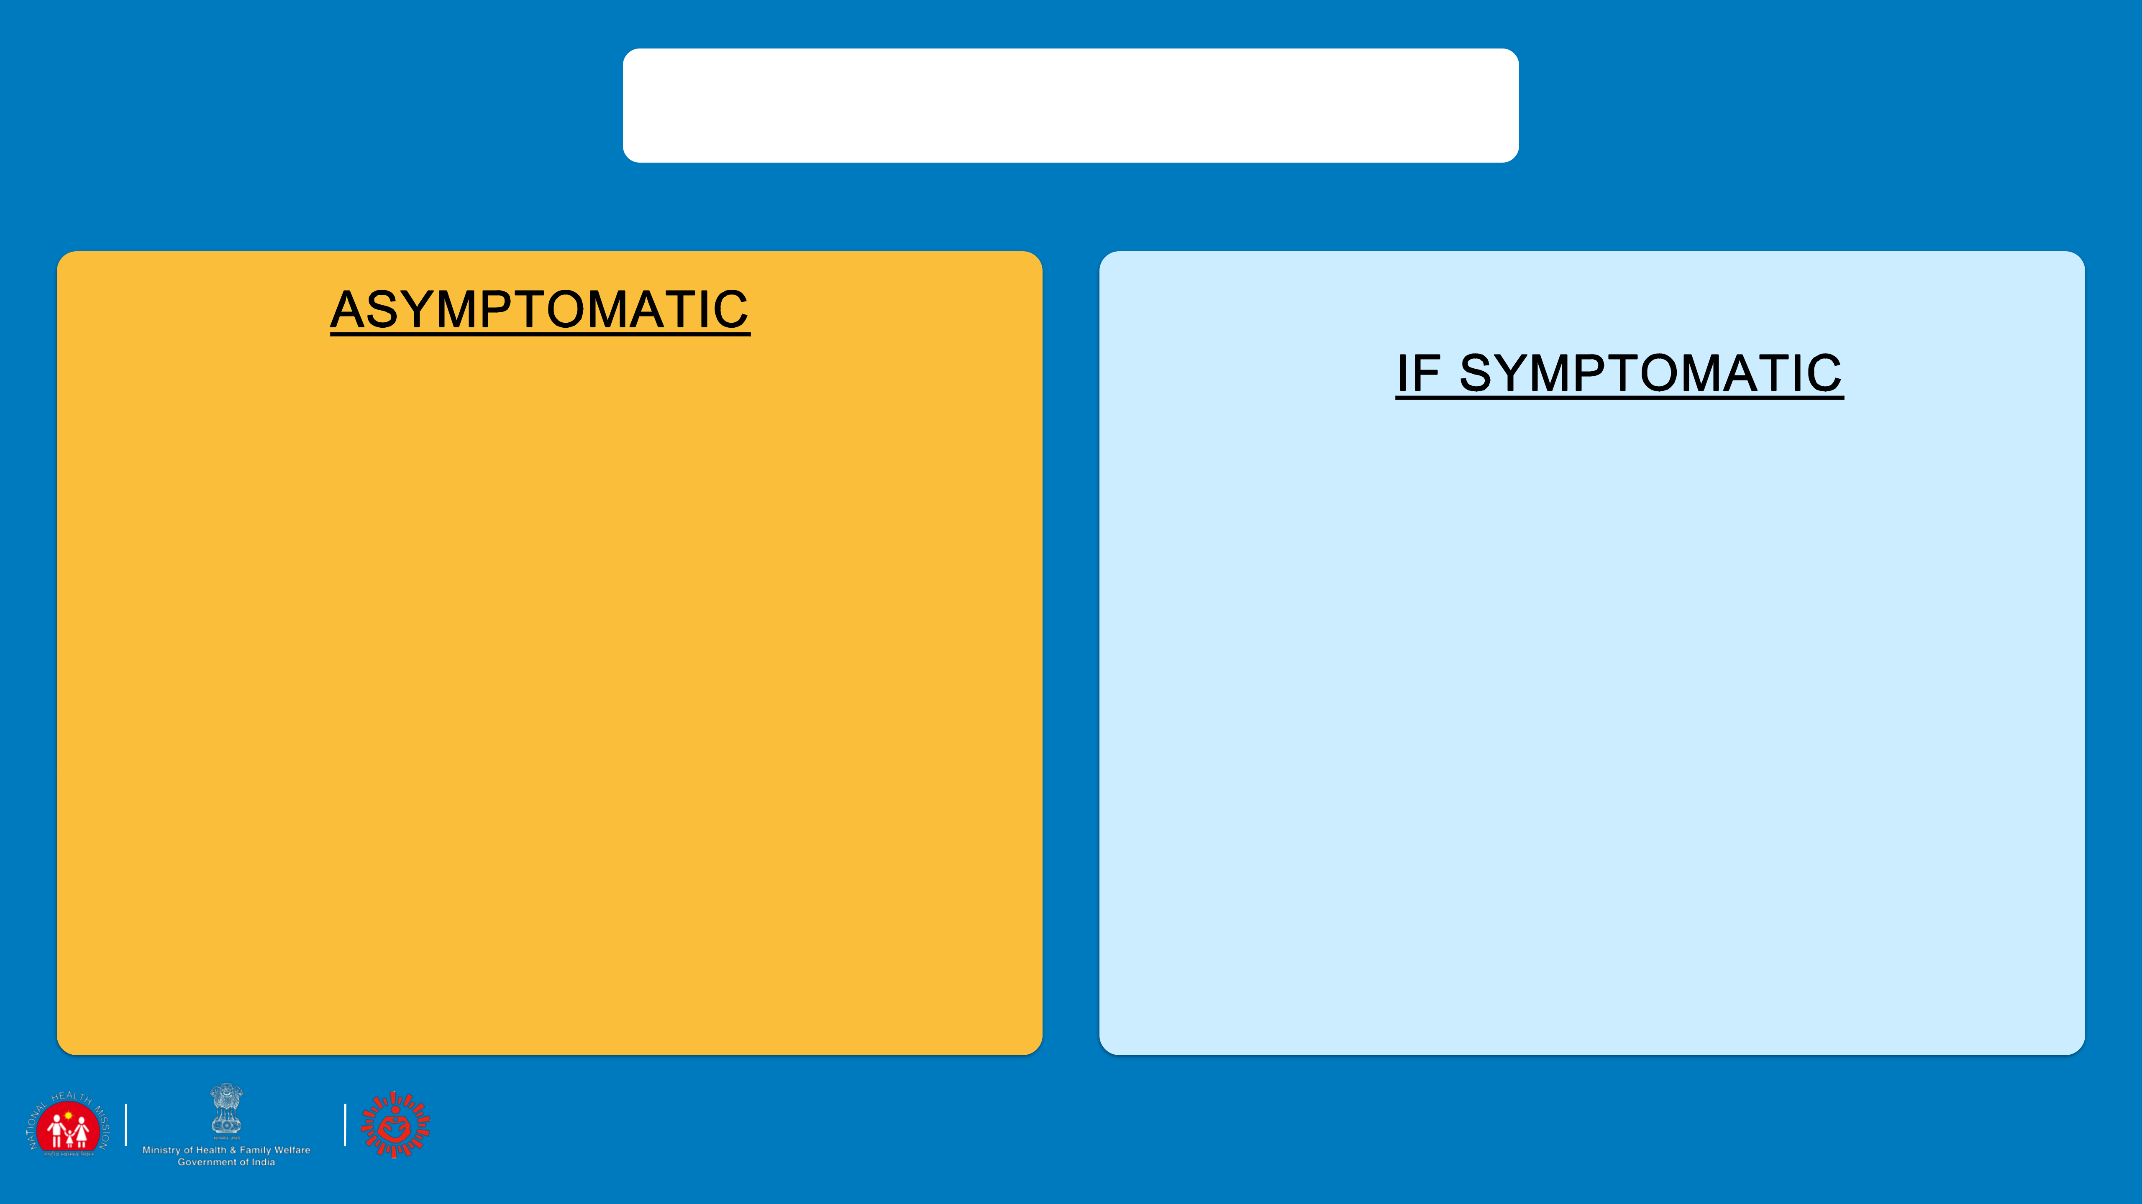

ADVISORY FOR CONTACTS

1. Home quarantine for at least 28 days after the last exposure with the case.
2. Initiate self-health monitoring for development of fever or cough and maintain a list of contacts on daily basis.
3. Active monitoring (eg. Daily visits or telephone calls) for 28 days after the last

exposure shall be done by ANM/ASHA/identified person

1. Direct and high-risk contacts of a confirmed case should be tested once between day 5 and day 14 of coming inn his/her contact
2. If symptoms develop (fever, cough, difficulty in breathing), use mask, self-isolate and immediately inform ANM / ASHA/ the identified local health official by telephone

 17

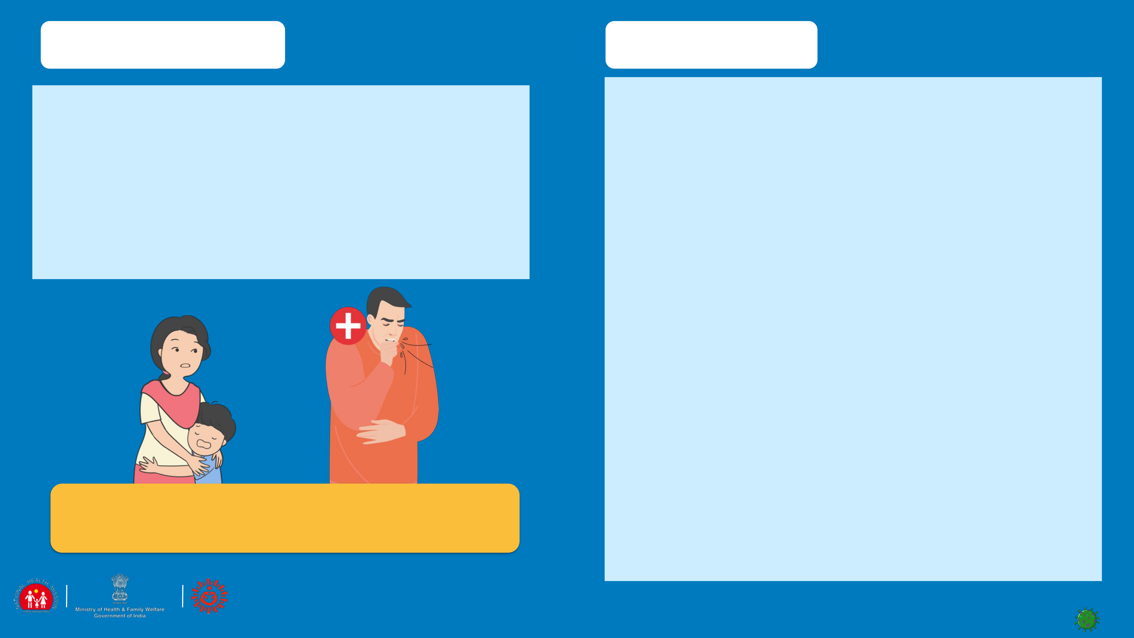CASE SCENARIO

SUNIL IS A YOUNG MAN OF 30 YEARS. HE WORKS IN MUMBAI AS A TEACHER IN A SMALL

SCHOOL AND HAS RETURNED BACK HOME

FOR HOLI. SUNIL HAS BEEN CONFIRMED WITH COVID-19 AND NOW HIS FAMILY IS WORRIED.

QUESTION: WHAT WILL YOU DO?

ANSWERS

* ENSURE THAT ALL MEMBERS IN THE FAMILY HAVE BEEN GIVEN THE ADVISE TO FOLLOW
* FOLLOW UP IF ANY HELP NEEDED
* ORGANISE FOR THE FAMILIES TO HAVE SUPPORT WHEN THEY ARE ON QUARANTINE FOR GETTING THEIR DAILY SUPPLIES LIKE GROCERIES OR VEGETABLES.
* CHECK ON HAND HYGIENE AND RESPIRATORY HYGIENE UNDERSTANDING
* CHECK IF ALL CLOTHES AND HOUSEHOLD MATERIALS USED BY CONFIRMED FAMILY MEMBER HAVE BEEN DISINFECTED.
* TALK TO THE FAMILY OFTEN EVEN IF ONLY ON THE MOBILE AND ENCOURAGE OTHER FRIENDS OF THE FAMILY TO TALK ON THE PHONE. THIS IS TO HELP THEM MANAGE THE FEELING OF BEING ISOLATED.

18

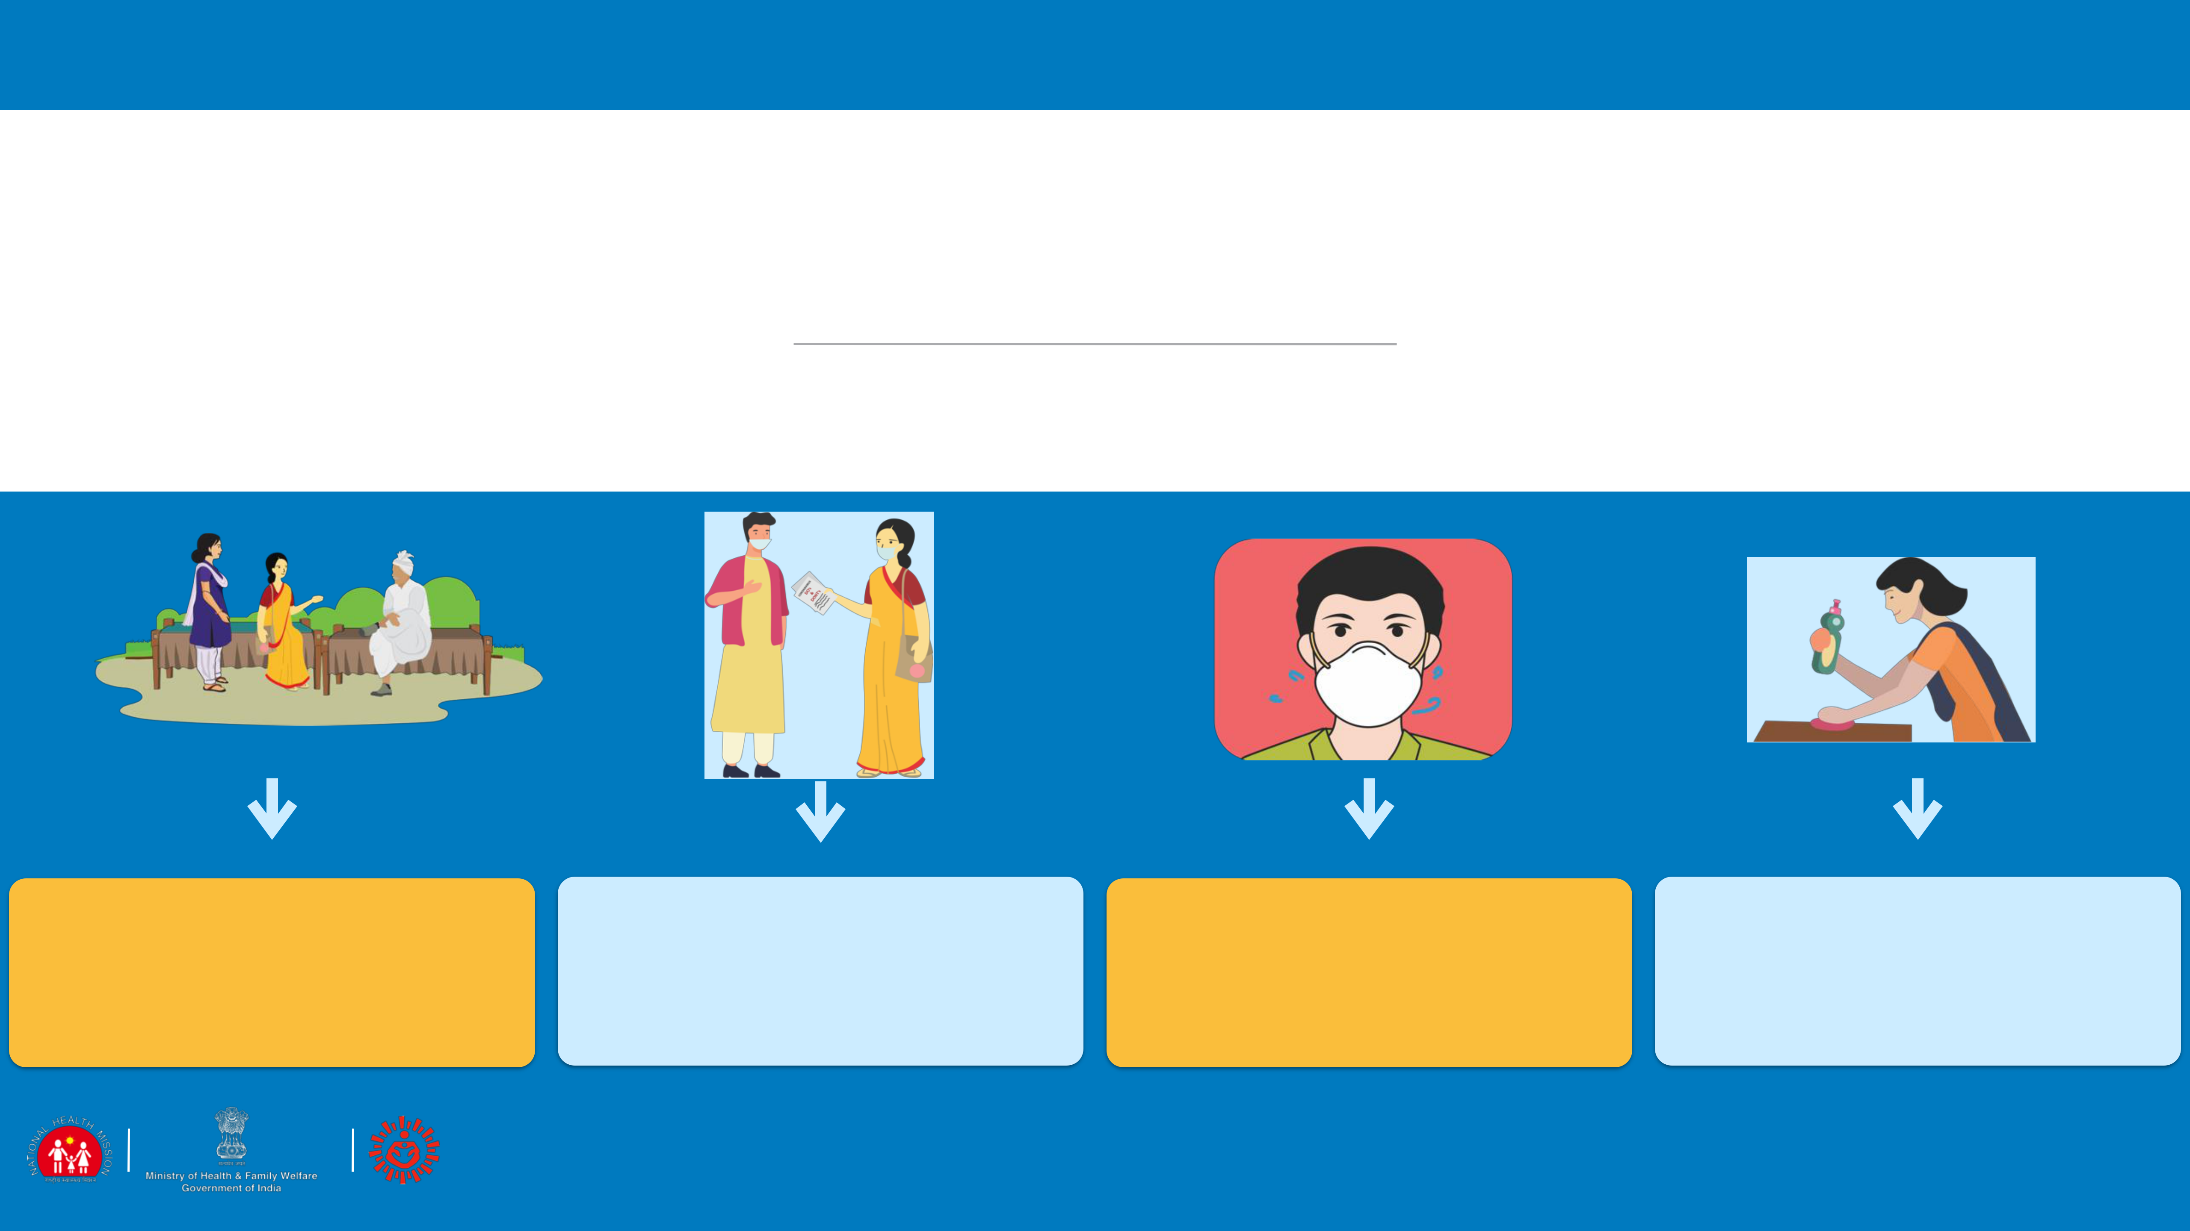

SESSION 4

SUPPORTIVE PUBLIC HEALTH SERVICES: COMMUNITY HOUSEHOLDS

|  |  |  |  |  |
| --- | --- | --- | --- | --- |
| CREATE |  | HOME |  |  |
| HOME |  |  |
| SUPPORTIVE | QUARANTINE- | HOMECARE |  |
| QUARANTINE -SELF |  |
| ENVIRONMENT | FAMILY MEMBERS |  |  |
|  |  |
|  |  |  |
|  |  |  |

 19



RESPONSE AND CONTAINMENT– CREATE A SUPPORTIVE ENVIRONMENT

TALK TO AND

INVOLVE INFLUENCERS FIGHT DISCRIMINATION

* MAKE A LIST OF LOCAL INFLUENCERS (GRAM PRADHAN, RELIGIOUS LEADERS, TEACHERS, ANY OTHER)
* EXPLAIN & DISCUSS THE SITUATION AND PROTOCOLS/ORDERS/NOTIFICA TIONS TO BE FOLLOWED AND SEEK THEIR SUPPORT IN GIVING KEY MESSAGES.
* SUPPORT ASSIGNING ROLES FOR COMMUNITY NETWORKS

PLAN COMMUNITY

SUPPORT FOR HIGH RISK

•MAKE A LIST OF HIGH RISK GROUPS IN THE VILLAGE

•IDENTIFY PEOPLE THEY MEET OR TALK TO; SHARE PREVENTIVE MEASURES WITH THESE PEOPLE AND REQUEST THEM TO KEEP COMMUNICATING THESE MEASURES TO THE HIGH RISK PEOPLE

•TAKE CARE OF OLDER PEOPLE OR PEOPLE WITH CO - MORBIDITIES LIKE HYPERTENSION, DIABETES, LUNG OR KIDNEY DISEASE.

•TAKE CARE OF CHILDREN WHOSE PARENTS MAY BE IN QUARANTINE FOR ISSUES OF EDUCATION AND/OR CARE.

COORDINATE WITH

THE EXISTING COMMUNITY NETWORKS FOR SUPPORT

•COORDINATE WITH THE EXISTING

GROUPS LIKE SHGS, YOUTH

NETWORKS, VHSNC ETC ON THE

ROLES ASSIGNED FOR EMERGENCY PLANNING, DISTRIBUTION OF SERVICES

LIKE FOOD/GROCERY DELIVERY FOR QUARANTINED HOUSEHOLDS, MIDDAY MEALS MEDICINE ETC.

•SHARE CONTACT DETAILS OF ANM,

ASHA, AMBULANCE, AND OTHER

MEDICAL SUPPORT WITH THEM

•SHARE COORDINATING DETAILS OF

CHILD PROTECTION COMMITTEES FOR

ADDRESSING ISSUES OF TRAUMA AND VIOLENCE IN CHILDREN.

HELP DEVELOP HOUSEHOLD EMERGENCY CONTACT LIST

•ENSURE EACH HOUSEHOLD HAS A CURRENT LIST OF EMERGENCY CONTACTS FOR FAMILY, FRIENDS, NEIGHBOURS, ESSENTIAL SERVICES CONTACT NUMBERS LIKE FOOD,

MEDICINES, MEDICAL HELP .

 20

CASE STUDY

BABULAL HAS BEEN RENTING OUT HIS TRACTOR FOR THE LAST SEVERAL YEARS AND MANY PEOPLE KNOW HIM IN THE COMMUNITY. RECENTLY PEOPLE HAVE STOPPED TAKING BABAULAL’S TRACTORS ON RENT AND YOU COME TO KNOW THAT THIS IS BECAUSE BABULAL HAS BEEN HAVING SYMPTOMS OF COLD AND FLU. WHEN YOU SPEAK WITH BABULAL HE TELLS YOU THAT WHEN HE IS WALKING PEOPLE CROSS OVER ON THE OTHER SIDE OF THE STREET AND DO NOT EVEN TALK TO HIM OR HIS FAMILY MEMBERS, INCLUDING HIS CHILDREN EVEN ON THE PHONE. HE HAS DECIDED TO GO TO HIS CITY HOUSE SO HE DOES NOT HAVE TO BEAR THIS BEHAVIOUR

ROLE OF AN INFLUENCER



QUESTION 1: IS THIS THE RIGHT THING TO DO?

QUESTION 2: WHAT WILL YOU DO AS THE LOCAL HEALTH WORKER?

* CHECK WHO CAN HELP IN INFLUENCING THE LOCAL LANDOWNERS.
* USE THE KEY INFLUENCERS IN GIVING THE COMMUNICATION ON WHAT IS COVID AND WHAT ARE THE SYMPTOMS.
* TALK TO THE DHO/MO FOR DISCUSSING THE SYMPTOMS OF COVID WITH BABULAL AND IF HE IS A CONTACT WHAT ADVISORY SHOULD BE GIVEN TO HIM

 21



HOME QUARANTINE: STAY SAFE FOR PROBABLE INFECTED PERSON

RESTRICTED MOVEMENT FOR COVID-19 SUSPECTS

KEEP DISTANCE

* STAY IN A WELL VENTILATED SPECIFIC ROOM AND AWAY FROM OTHER PEOPLE IN YOUR HOME. RESTRICT MOVEMENT
* IF AVAILABLE, USE A SEPARATE BATHROOM

SEEK HEALTH CARE AND NOTIFY

* IF SUFFERING FROM COUGH OR FEVER OR BREATHING DIFFICULTY AND SUSPECTING CONTACT, WEAR A MASK, AND NOTIFY NEAREST HEALTH FACILITY / ASHA/ANM IMMEDIATELY.

WEAR A MASK

AVOID VISITORS IN THE HOUSE

* BECAUSE IF INFECTED YOU CAN SPREAD INFECTION TO OTHERS

AVOID GOING TO PUBLIC AREAS

* DO NOT GO TO WORK, SCHOOL, OR PUBLIC AREAS LIKE MARKETS, CINEMAS ETC.
* AVOID USING PUBLIC TRANSPORT
* WEAR A MASK CORRECTLY WHEN YOU ARE AROUND

OTHER PEOPLE AND WHENEVER YOU ENTER A HEALTHCARE PROVIDER’S CLINIC

 22

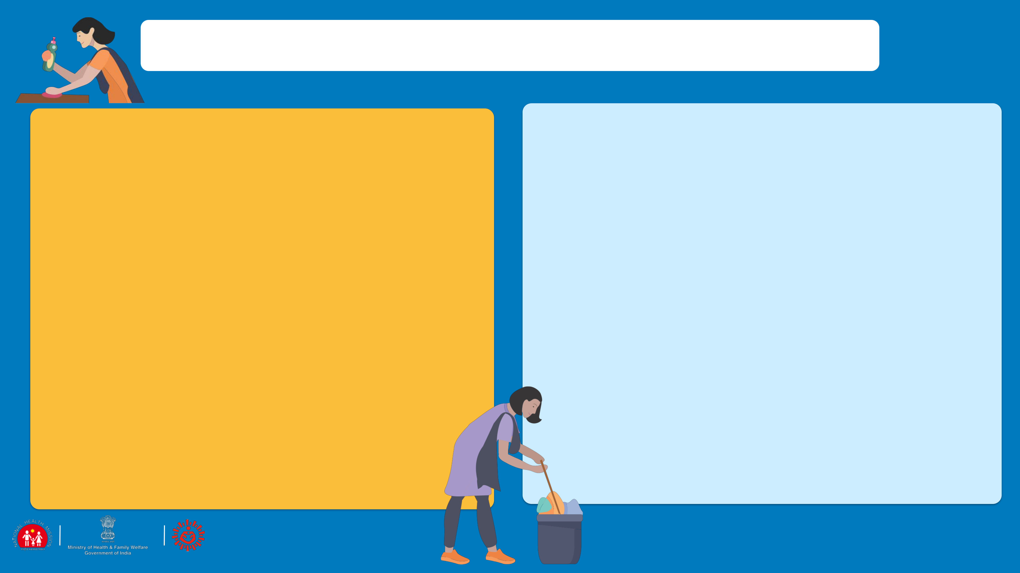

HOME CARE: KEEP ENVIRONMENT SAFE

PRECAUTIONS TO BE TAKEN BY THE HOUSEHOLD WHERE THERE IS A SUSPECTED CASE

* SUPPORT: ASSIGNED FAMILY MEMBER TO TAKE CARE OF

INFECTED PERSON HELPING THEM FOLLOW DOCTOR’S

INSTRUCTIONS FOR MEDICATION(S) AND CARE.

* WASH HANDS: WITH SOAP AND WATER FOR AT LEAST 40 SECONDS OR, IF SOAP AND WATER ARE NOT AVAILABLE, CLEAN YOUR HANDS WITH AN ALCOHOL-BASED HAND SANITIZER THAT CONTAINS AT LEAST 70% ALCOHOL. WASH OFTEN AND ESPECIALLY AFTER TOUCHING
* CLEAN AND DISINFECT: ALL “HIGH-TOUCH” SURFACES,

SUCH AS TABLETOPS, DOORKNOBS, BATHROOM FIXTURES, TOILETS, PHONES, EVERY DAY. ALSO, WIPE ANY SURFACES THAT MAY HAVE BLOOD, STOOL, OR BODY FLUIDS ON THEM. USING BLEACHING POWDER SOLUTION (4 TSP OF HOUSEHOLD BLEACH IN 4 CUPS OF WATER)

WASH LAUNDRY THOROUGHLY AND AVOID SHAKING SOILED LINEN

* IMMEDIATELY REMOVE AND WASH CLOTHES OR BEDDING THAT HAVE BLOOD, STOOL, OR BODY FLUIDS ON THEM. KEEP AWAY FROM BODY.
* WASH AND DISINFECT LINEN IN WARM WATER AND SOAP, DRY IN SUN
* WASHING MACHINE: USE DISINFECTANT, SOAP, WARM WATER, DRY IN SUN
* LINEN CAN BE SOAKED IN HOT WATER AND SOAP IN A LARGE DRUM, USING A STICK TO STIR, AVOIDING SPLASHING (SOAK LINEN IN 1% CHLORINE FOR APPROXIMATELY 30 MINUTES. FINALLY, RINSE WITH CLEAN WATER AND LET LINEN DRY FULLY IN THE SUNLIGHT.
* PLACE ALL USED DISPOSABLE GLOVES, FACEMASKS, AND OTHER CONTAMINATED ITEMS IN A LINED CONTAINER BEFORE DISPOSING OF THEM WITH OTHER HOUSEHOLD WASTE.
* NOTE: INFECTED PERSON MAY BE AMBULATORY OR BED-RIDDEN

 23

HOME QUARANTINE: STAY SAFE FOR FAMILY MEMBERS

* HOUSEHOLD MEMBERS SHOULD STAY IN ANOTHER ROOM OR BE SEPARATED FROM THE PATIENT AS MUCH AS POSSIBLE.

•

•

HOUSEHOLD MEMBERS SHOULD USE A SEPARATE BEDROOM AND BATHROOM, IF AVAILABLE.

AVOID SHARING HOUSEHOLD ITEMS E.G. DISHES, DRINKING GLASSES, CUPS, EATING UTENSILS, TOWELS, BEDDING, OR OTHER ITEMS WITH OTHER PEOPLE AT HOME.

* WASH HAND AS OFTEN THOROUGHLY WITH SOAP AND WATER (40 SECS) OR WITH 70% ALCOHOL-BASED HAND SANITISER
* WHEN IN CONTACT WITH THE PERSON WHO IS QUARANTINED, THE FAMILY MEMBERS SHOULD WEAR A THREE LAYERED MASK AT ALL THE TIMES. DISPOSABLE MASKS ARE NEVER TO BE REUSED.
* USED MASK SHOULD BE CONSIDERED AS POTENTIALLY INFECTED. DISPOSE MASK BY SOAKING IN HOME BLEACH SOLUTION AND THEN THROWING IN A DUSTBIN.
* DO NOT LET SMALL CHILDREN PLAY WITH THE MASKS.

 24

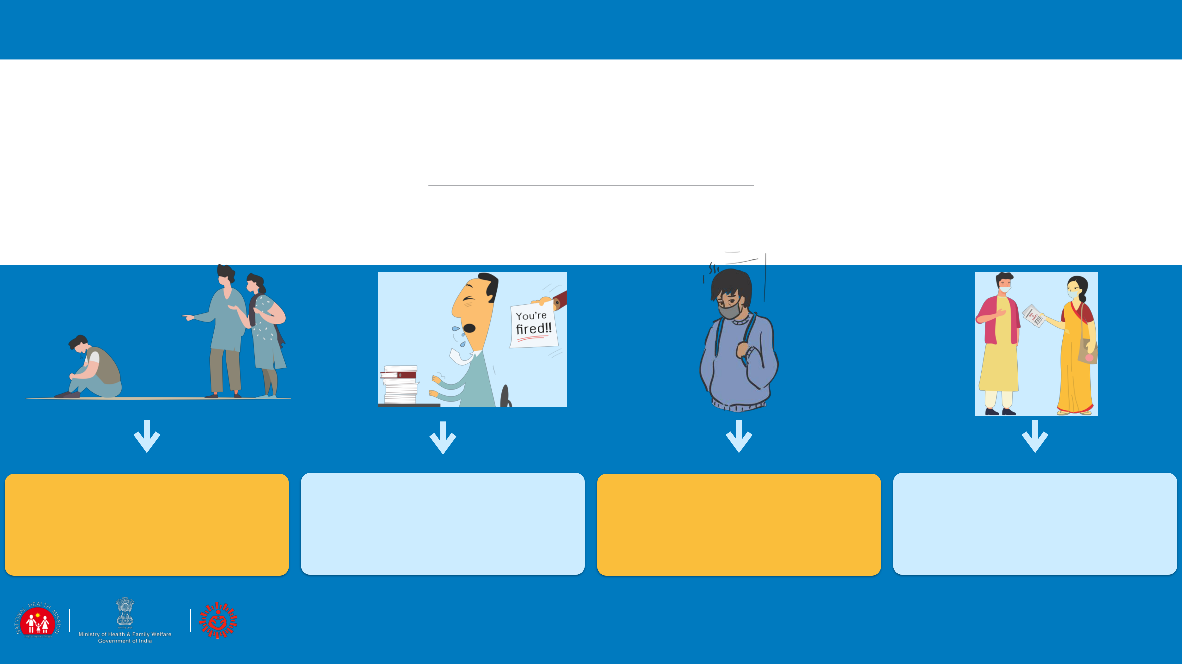

SESSION 5

STIGMA AND DISCRIMINATION

|  |  |  |  |
| --- | --- | --- | --- |
| WHAT IS | WHY IS THERE | WHAT DOES | WHATCAN |
| STIGMA? | STIGMA? | STIGMA DO? | FLWDO? |
|  |  |  |  |

 25

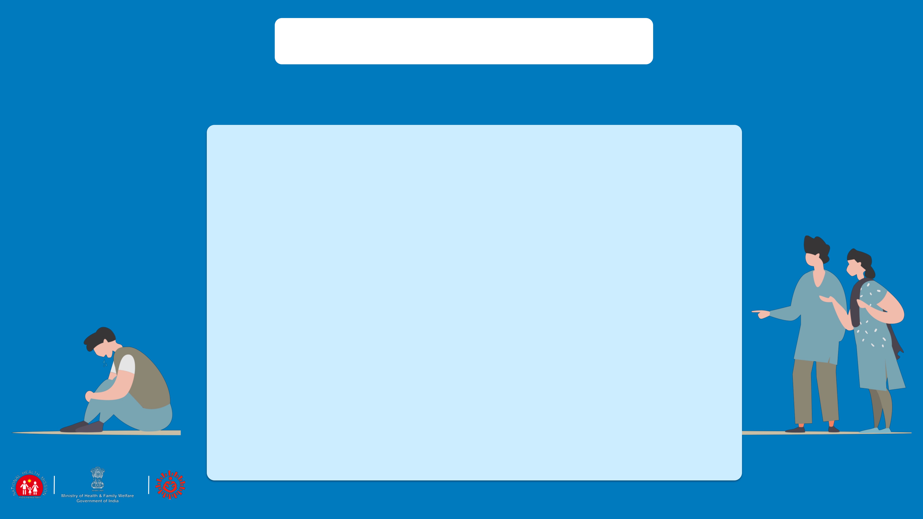

WHAT IS STIGMA?

IN ANY EPIDEMIC, IT IS COMMON FOR INDIVIDUALS TO FEEL

STRESSED AND WORRIED BECAUSE THEY FEAR:

•

•

FALLING ILL AND DYING

AVOIDING APPROACHING HEALTH FACILITIES DUE TO FEAR OF BECOMING INFECTED WHILE IN CARE

* FEAR OF LOSING LIVELIHOODS, NOT BEING ABLE TO WORK DURING ISOLATION, AND OF BEING DISMISSED FROM WORK
* FEAR OF BEING SOCIALLY EXCLUDED/PLACED IN QUARANTINE BECAUSE OF BEING ASSOCIATED WITH THE DISEASE
* FEELING POWERLESS IN PROTECTING LOVED ONES AND FEAR OF LOSING LOVED ONES BECAUSE OF THE VIRUS OR BEING SEPARATED DURING QUARANTINE
* FEELINGS OF HELPLESSNESS, BOREDOM, LONELINESS AND DEPRESSION DUE TO BEING ISOLATED AND NOT WORKING TOWARDS CARING FOR A DEPENDENT
* STRESS IS CAUSED DUE TO THE ABOVE FEARS AND BEING TREATED AS AN OUTCASTE OR BLAMED FOR SPREADING THE DISEASE

 26



WHY IS THERE STIGMA?

THE LEVEL OF STIGMA ASSOCIATED WITH COVID-19 IS BASED ON THREE MAIN FACTORS:

▪COVID-19 IS A NEW DISEASE ABOUT WHICH MANY THINGS ARE STILL BEING DISCOVERED.

▪WHEN SOMETHING IS UNKNOWN PEOPLE ARE WORRIED WHICH LEADS TO FEAR

▪RUMOURS OR FAKE NEWS GIVE WRONG INFORMATION AND SPREADS THE FEAR.

 27

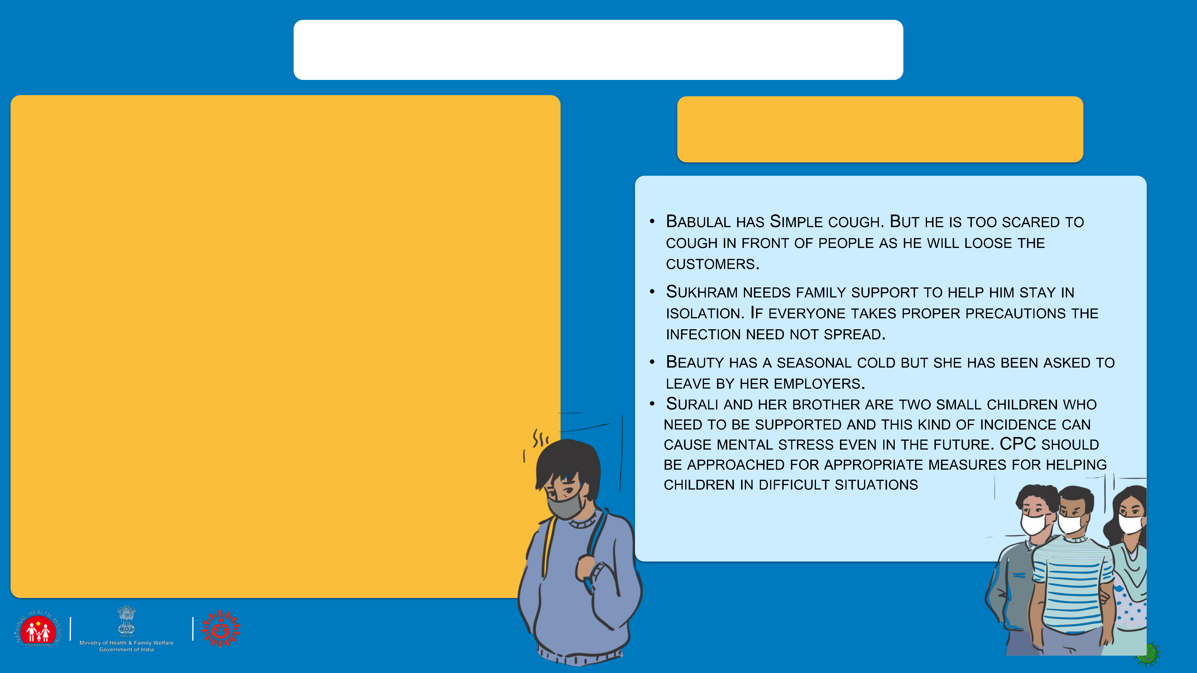RECOGNISING STIGMA?

1. YOU ARE IN THE GROCERY SHOP. THERE ARE SEVERAL PEOPLE WHO ARE WEARING A MASK. YOU SEE BABULAL THE STORE OWNER GOING RED IN HIS FACE AS HE TRIES TO SUPPRESS A COUGH.
2. SUKHRAM HAS COME BACK FROM PUNE WHERE HE WORKS AS A TAXI DRIVER. THEY STAY IN A JOINT FAMILY AND YOU HAVE TAKEN HIS CONTACT HISTORY AS ADVISED BY YOUR SUPERVISOR. YOU COME TO KNOW THAT SUKHRAM’S FAMILY MEMBERS HAVE ASKED HIM TO LEAVE THE HOUSE
3. BEAUTY WORKS IN DELHI AS A HOUSE MAID. RECENTLY SHE HAS

COME BACK AND YOU HAVE BEEN TOLD THAT BEAUTY’S

EMPLOYERS HAVE ASKED HER TO LEAVE AS SHE HAD A COLD.

1. SURALI IS A YOUNG GIRL OF 11 YEARS. SHE AND HER 8 YEAR OLD BROTHER ARE STAYING WITH AN AUNT AS THEIR PARENTS HAVE BEEN ASKED TO GO IN FOR ISOLATION. SURALI’S AUNT KEEPS ON COMPLAINING TO YOU THAT THE CHILDREN ARE A BIG

BURDEN ON THE FAMILY’S RESOURCES.

WHAT WILL YOU FEEL LIKE IF YOU WERE

BABULAL, RANI, SUKHRAM, BEAUTY?

THE STIGMA

28

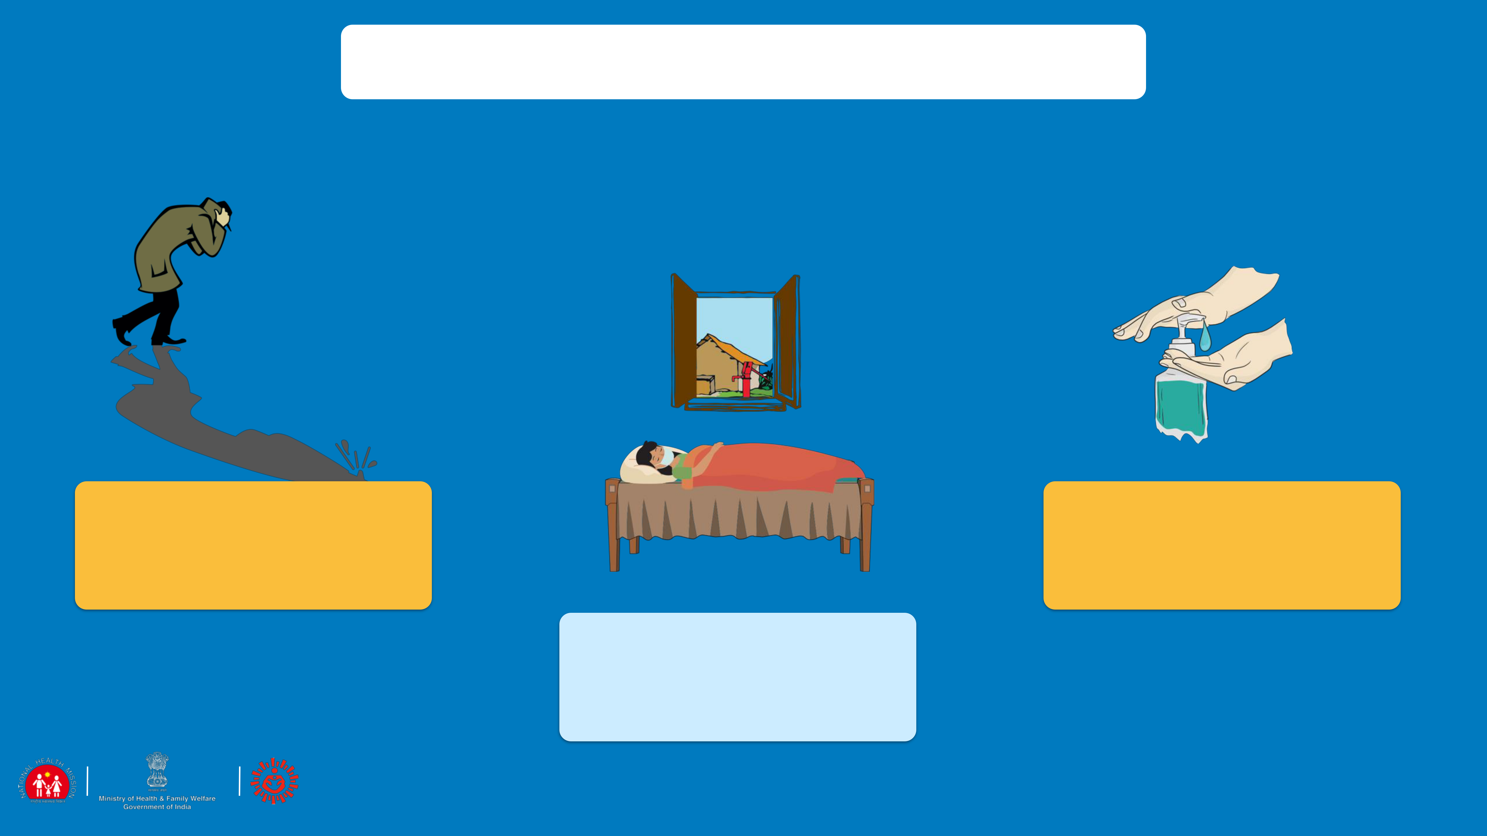

WHAT DOES STIGMA DO?

DISCOURAGES THEM &

MAKES PEOPLE HIDE MAY AT TIMES PREVENT

THEIR PROBLEMS THEM FROM ADOPTING

HEALTHY BEHAVIOURS

KEEPS PEOPLE AWAY

FROM ACCESSING

HEALTH SERVICES AND

SEEKING HELP

 29



WHAT CAN THE FLW DO?

AS A HEALTH WORKER, YOU CAN:

•

•

•

•

•

SENSITIZE PEOPLE AND HELP THEM TO UNDERSTAND THAT IT IS A SIMPLE INFECTION AND 80% OF THE CASES ARE MILD

CASES.

COVID-19 CAN HAPPEN TO ANYONE, SPEAK TO PEOPLE, BE AVAILABLE TO LISTEN TO HOW THEY FEEL

ADVISE PEOPLE TO ENGAGE IN RELAXING ACTIVITIES LIKE INDOOR GAMES, READING, GARDENING, HOME-CLEANING, ETC. ASK PEOPLE TO STAY AWAY FROM WATCHING NEGATIVE THINGS ON THE TV AND ALSO FAKE NEWS

ENGAGE COMMUNITY INFLUENCERS , SHARE CORRECT INFORMATION ON COVID-19 WITH THEM. BRIEF THEM ON SPECIFIC

SUPPORT REQUIRED BY YOU. GUIDE WHATSAPP GROUPS TO HELP IN GIVING HOPE AND POSITIVE NEWS TO HELP PEOPLE

HANDLE STRESS.

* PUBLICLY, USE TERMS LIKE PEOPLE WHO HAVE COVID-19 INSTEAD OF “COVID-19 CASES” OR “VICTIMS”. SIMILARLY, USE TERMS LIKE PEOPLE WHO MAY HAVE COVID-19 INSTEAD OF “SUSPECTED CASES”
* EMPHASIZE THAT MOST PEOPLE DO RECOVER FROM COVID-19, AMPLIFY THE GOOD NEWS ABOUT LOCAL PEOPLE . WHO HAVE RECOVERED FROM COVID-19? WHO HAVE SUPPORTED A LOVED ONE THROUGH RECOVERY?
* MAKE SPECIAL EFFORTS TO REACH OUT TO HIGH RISK GROUPS INCLUDING SENIOR CITIZENS AND YOUNGER CHILDREN.

 30



CASE FROM PIPLI: WHAT CAN FLW DO?

Suresh was under home quarantine when his wife, developed labour pains and had to be taken to the hospital for delivery. The ASHA assured Suresh that his wife will be taken care of while he should remain isolated within the house as advised. The ASHA called her neighbour Seema and requested her to send food for Suresh. She reminded Seema to take the precautions while giving food. She then called the convener of local mothers’ group and a member of village health and nutrition committee (VHSNC) member and apprised both of them of the situation requesting them to arrange for Suresh’s food and home-care requirements. The VHSNC member requested village youth group members to do the needful for Suresh at-least for next 72 hours till his wife returns.

1. What are the positive actions taken by ASHA?

ASHA has proactively formed community support groups and planned in case of emergency

1. What should be done?

She informed her neighbour to give food

* 1. Which groups and /or people were involved by ASHA to provide supportive environment?

The neighbours, VHSNC (who in turn involved the Youth Groups) and Adolescent Girls groups

* 1. If you were in place of ASHA, what would you have done additionally?

 31

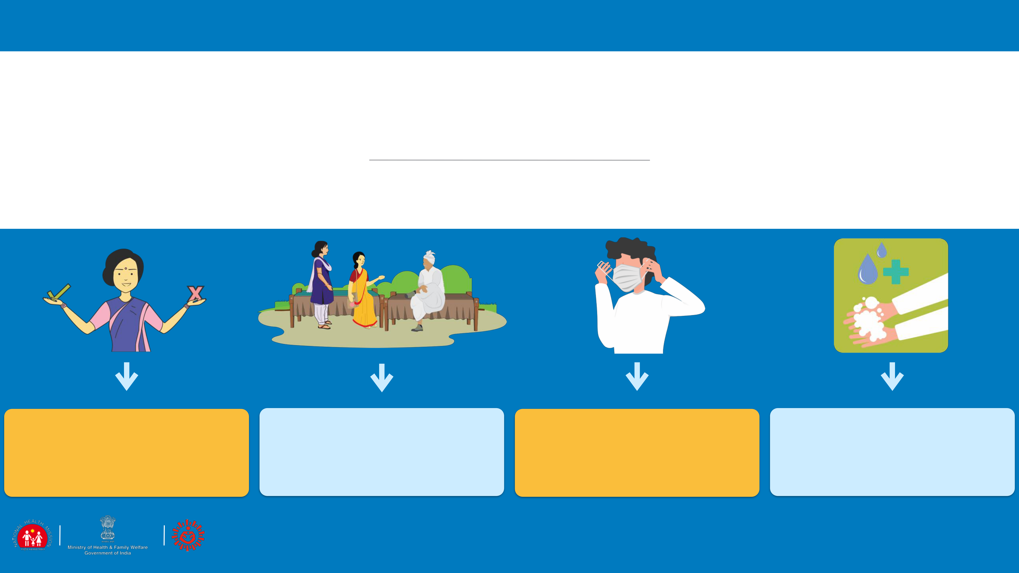

SESSION 6

COMMUNICATION, PERSONAL SAFETY FOR HEALTH/ICDS PERSONNEL

|  |  |  |  |  |
| --- | --- | --- | --- | --- |
| WHAT TO | HOW TO | MASK | PRECAUTIONS |  |
| COMMUNICATE | COMMUNICATE? | MANAGEMENT |  |
|  |  |

 32

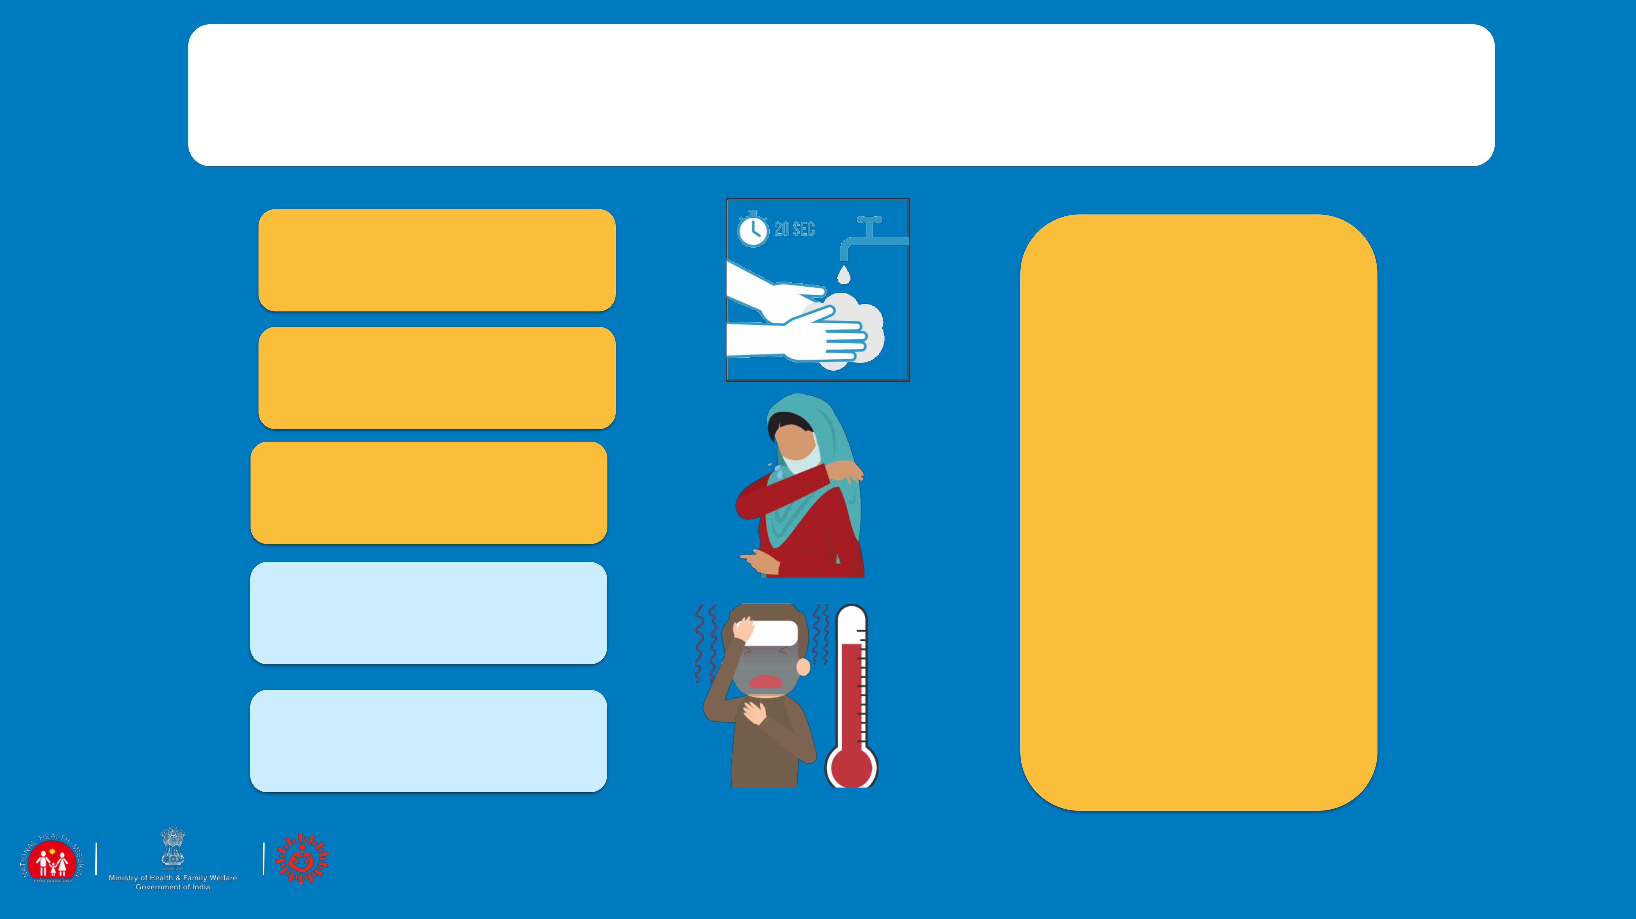

WHAT TO COMMUNICATE AND

COMMUNICATION PLATFORMS

HAND HYGIENE

RESPIRATORY

HYGIENE

SOCIAL DISTANCING

HOME CARE &

HOME

QUARANTINE

MONITORING

SYMPTOMS

* SHARE MOBISODES
* DISPLAY IEC MATERIALS AT APPROPRIATE PLACES
* USE ESSENTIAL SERVICES (LIKE GARBAGE COLLECTION VANS, MILK SUPPLY, ETC.) FOR MIKING
* SHARE WHATSAPP MESSAGES ON GROUPS
* USE POCKET BOOK FOR GIVING KEY MESSAGES

 33



COMMUNICATION: HOW?

* ALWAYS BE POLITE. ANYONE CAN GET THE INFECTION, ANYWHERE. DO NOT DISCRIMINATE, SHOUT, OR USE RUDE LANGUAGE.
* TELL PEOPLE ABOUT THE PURPOSE OF YOUR VISIT AND WHAT YOU WILL DO WITH THE ANSWERS YOU ARE SEEKING. SAY THAT THIS IS THE SUPPORT THAT THE GOVERNMENT IS GIVING ALL CITIZENS.
* GATHER ACCURATE INFORMATION FROM THE PATIENT: THEIR NAME, DATE OF BIRTH, TRAVEL HISTORY, LIST OF SYMPTOMS, RECORD AND COMMUNICATE AS PER THE SURVEILLANCE FORMAT. WRITE THE INFORMATION CLEARLY
* BE AWARE THAT SUSPECTED AND CONFIRMED CASES, AND ANY VISITORS ACCOMPANYING THEM, MAY BE STRESSED OR AFRAID. SO, THE MOST IMPORTANT THING YOU CAN DO IS TO LISTEN CAREFULLY TO QUESTIONS AND CONCERNS.
* WHEN YOU MEET PEOPLE, AVOID TOUCHING OR DIRECT PHYSICAL CONTACT. THIS IS TRUE FOR PASSING ON INFECTION EITHER WAY. MAINTAIN DISTANCE OF MORE THAN 1 METER WHEN YOU INTERACT.
* IT IS BETTER TO SIT IN THE OPEN AND SPEAK WITH THE FAMILY MEMBERS IF SPACE AND SITUATION ALLOWS.
* ASK QUESTIONS AND GET VERY SPECIFIC ANSWERS. WHEN YOU ARE WRITING, MAKE SURE YOUR WRITING IS CLEAR AND COMPLETE INFORMATION (ADDRESSES, NAMES, CONTACT NUMBERS) IS WRITTEN LEGIBLY.
* CHECK IF PEOPLE HAVE UNDERSTOOD YOUR MESSAGE BY ASKING THEM TO REPEAT WHAT YOU HAVE TOLD.
* IF THERE ARE QUESTIONS AND YOU HAVE THE ANSWERS, YOU MUST SHARE THIS WITH THE COMMUNITY MEMBER. HOWEVER IF YOU DO NOT HAVE THE ANSWER, DO NOT HESITATE TO SAY SO. A LOT IS STILL UNKNOWN ABOUT COVID-19

 34

MASK MANAGEMENT

USE A MASK IF AND ONLY WHEN:

* YOU DEVELOP FEVER, COUGH OR DIFFICULTY IN BREATHING
* YOU VISIT A HEALTH CARE FACILITY.
* YOU ARE CARING FOR AN ILL PERSON
* WHEN CONTACT TRACING

USE A MASK CORRECTLY:

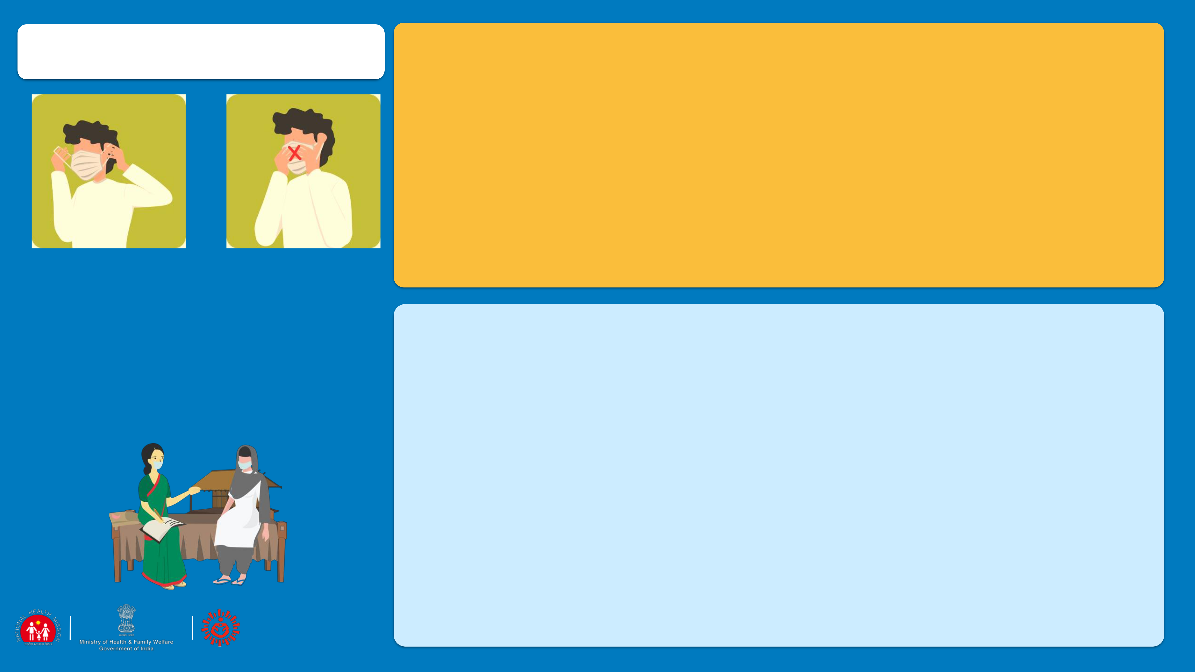

* UNFOLD PLEATS, FACING DOWN, PLACE OVER NOSE, MOUTH AND CHIN.
* FIT NOSE PIECE OVER NOSE-BRIDGE. TIE STRINGS UPPER STRING TIED - TOP OF HEAD ABOVE EARS LOWER STRING AT THE BACK OF THE NECK.
* LEAVE NO GAPS ON EITHER SIDE OF THE MASK, ADJUST TO FIT.
* DO NOT PULL THE MASK DOWN OR HANG FROM THE NECK
* AVOID TOUCHING THE MASK WHILE IN USE.
* REPLACE MASKS WITH A NEW CLEAN, DRY MASK AS SOON AS THEY BECOME DAMP/HUMID, 6 -8 HOURS

REMOVING AND DISPOSING THE MASK

* DO NOT RE-USE SINGLE-USE MASKS
* DO NOT TOUCH OTHER SURFACES OF THE MASK WHILE REMOVING.
* TO REMOVE MASK FIRST UNTIE THE STRING BELOW AND THEN THE STRING ABOVE AND HANDLE THE MASK USING THE UPPER STRINGS. OTHER SURFACES MAY BE POTENTIALLY CONTAMINATED
* REMOVE THE MASK BY USING APPROPRIATE TECHNIQUE (I.E. DO NOT TOUCH THE FRONT BUT REMOVE THE LACE FROM BEHIND)
* AFTER REMOVAL OR WHENEVER YOU INADVERTENTLY TOUCH A USED MASK, CLEAN HANDS BY USING A 70% ALCOHOL-BASED HAND RUB OR SOAP AND WATER FOR 40 SECS.
* DISCARD SINGLE-USE MASKS AFTER EACH USE AND DISPOSE OF THEM IMMEDIATELY UPON REMOVAL

 35

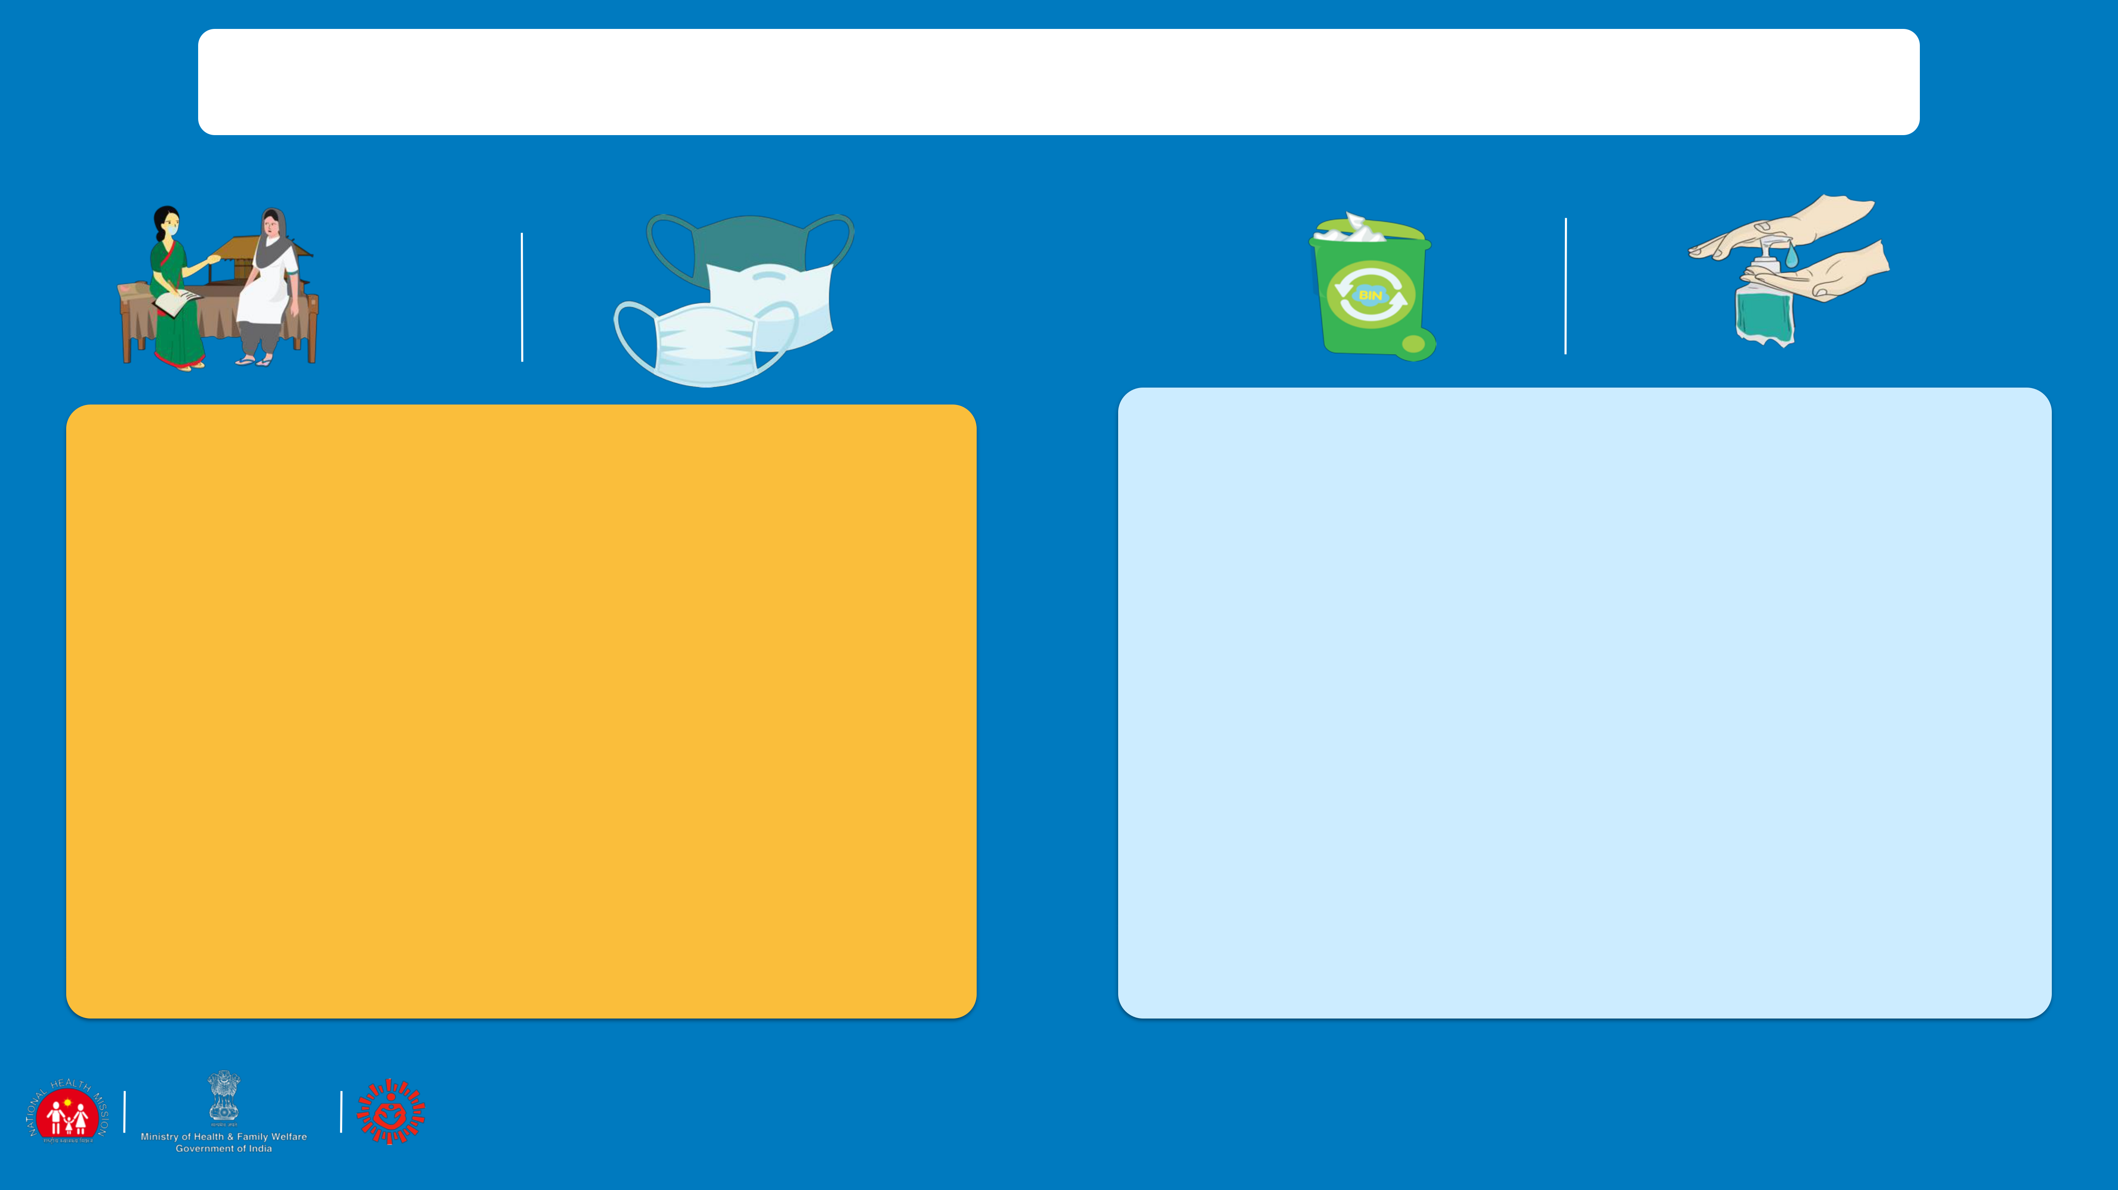

PRECAUTION AND SAFETY MEASURE FOR FLW

WHEN MOVING AROUND THE COMMUNITY

* MAINTAIN DISTANCE OF AT LEAST 1 METER FROM PEOPLE WHEN YOU ARE COMMUNICATING
* USE A THREE LAYERED MASK TO COVER YOUR FACE. MAKE SURE IT IS PROPERLY WORN.(WHILE CONTACT TRACING)
* AVOID TOUCHING YOUR FACE (EYES, NOSE, MOUTH) AT ALL TIMES
* WASH YOUR HANDS WITH SOAP AND WATER FREQUENTLY, OR USE ALCOHOL BASED HAND-RUB
* AVOID TOUCHING OR DIRECT PHYSICAL CONTACT

•

•

•

•

IMMEDIATELY ON REACHING HOME

CAREFULLY REMOVE AND DISPOSE OFF YOUR FACE MASK BY SOAKING IN BLEACH SOLUTION AND THEN THROWING IT IN A COVERED DUSTBIN. (SEE: MASK MANAGEMENT).

WASH YOUR HANDS WITH SOAP AND WATER OR ALCOHOL BASED HAND-SANITISER BEFORE YOU TOUCH ANYTHING ELSE.

WIPE DOWN WHAT YOU HAVE CARRIED LIKE YOUR PURSE AND MOBILE WITH HOME BASED DISINFECTANT (4 TSPS OF HOUSEHOLD BLEACH IN 4 CUPS OF WATER)

IF YOU GET ANY SYMPTOMS LIKE FEVER, COUGH OR DIFFICULTY IN BREATHING REPORT TO THE NEAREST GOVERNMENT FACILITY OR DISTRICT SURVEILLANCE OFFICER IMMEDIATELY.

 36



MYTHS & FACTS

STATEMENT: WITH THE SUMMERS COMING UP, THE CORONAVIRUS WILL BE KILLED

FACT: COVID-19 HAS BEEN DETECTED IN ALL AREAS, INCLUDING AREAS WITH HOT AND HUMID WEATHER. THE BEST WAY TO PROTECT YOURSELF AGAINST COVID-19 IS BY FREQUENTLY WASHING YOUR HANDS WITH SOAP AND WATER, COVERING YOUR COUGHS AND SNEEZES AND AVOIDING CROWDED PLACES.

STATEMENT: HAVING A BATH WITH HOT WATER WILL KILL THE VIRUS

FACT: THE VIRUS LIVES INSIDE THE BODY WHERE THE TEMPERATURE IS MAINTAINED AT 37ºC AND IS NOT AFFECTED BY A HOT WATER BATH THAT YOU HAVE.

STATEMENT: GETTING THE PNEUMONIA VACCINE WILL PROTECT YOU AGAINST THE VIRUS

FACT: WHILE VACCINES FOR PNEUMONIA WILL CERTAINLY PROTECT YOU AGAINST OTHER ORGANISMS THAT CAUSE PNEUMONIA, THE VACCINE FOR NOVEL CORONAVIRUS IS UNDER DEVELOPMENT.

STATEMENT: SPRAYING ALCOHOL OR DISINFECTANT OVER YOUR BODY CAN PREVENT INFECTION

FACT: SPRAYING WITH ALCOHOL OR SANITISER ON CLOTHES AND BODY WILL NOT PREVENT YOU FROM GETTING INFECTION. INFECTION SPREADS WHEN THE VIRUS ENTERS THE BODY THROUGH NOSE OR MOUTH. CLEANING AND WIPING HANDS WITH ALCOHOL IS TO PREVENT THE GERM FROM ENTERING YOUR SYSTEM THROUGH INFECTED HANDS WHEN YOU TOUCH YOUR MOUTH OR YOU EAT FOOD WITH INFECTED HANDS.

STATEMENT: REGULARLY RINSING THE NOSE WITH SALINE WILL PREVENT THE INFECTION

FACT: RINSING NOSE WITH SALINE HAS IN FEW CASES HELPED IN CONTAINING COMMON COLD, BUT HAS NO EVIDENCE TO SUGGEST IT IS EFFECTIVE AGAINST THE NOVEL CORONAVIRUS INFECTION

 37



MYTHS & FACTS

STATEMENT: CORONAVIRUS CAN BE PASSED THROUGH CHICKEN AND MEAT

FACT: NO! THERE IS NO SUCH EVIDENCE OF CORONAVIRUS SPREADING THROUGH MEAT AND POULTRY PRODUCTS. HOWEVER IT IS ALWAYS ADVISED TO HAVE PROPERLY COOKED MEAT AND CHICKEN.

STATEMENT: A PERSON WITH CORONAVIRUS CAN RECOVER FULLY AND BE NO MORE INFECTIOUS.

FACT: 80% OF THE PEOPLE HAVE RECOVERED FROM THE DISEASE WITHOUT NEEDING SPECIAL TREATMENT. BUT INFORMATION ON THE VIRUS TREATMENT IS STILL BEING RESEARCHED

STATEMENT: EATING RAW GARLIC, SESAME SEEDS WILL PROTECT YOU AGAINST THE VIRUS

FACT: GARLIC IS A HEALTHY FOOD THAT HAS OTHER BENEFITS BUT DOES NOT PROTECT YOU AGAINST THE CORONAVIRUS.

STATEMENT: THE VIRUS CAN DIE EASILY ONCE IT IS OUT OF THE BODY

FACT: WE DO NOT KNOW ABOUT THIS PARTICULAR VIRUS AS OF NOW. SIMILAR VIRUSES (SARS, MERS) SURVIVE FROM 8 TO 24 HOURS DEPENDING ON TYPES OF SURFACES.

STATEMENT: YOU CAN GET COVID-19 THROUGH MOSQUITO BITES

FACT: THE CORONAVIRUS CANNOT BE SPREAD THROUGH THE BITE OF A MOSQUITO. IT IS SPREAD THOROUGH DROPLETS SPREAD WHEN AN INFECTED PERSON SNEEZES OR COUGHS

 38



LET'S EXPOSE THE VIRUS

 39

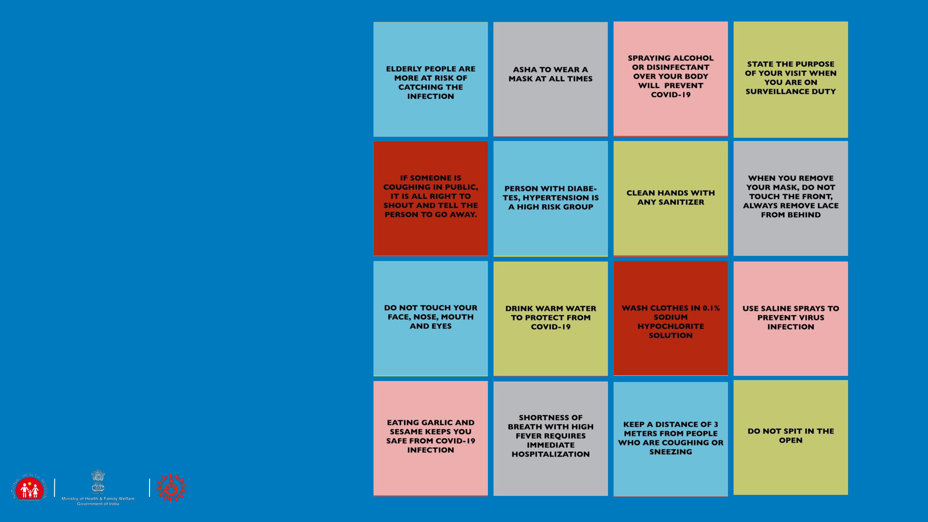

LET’S HEAR

YOUR

ANSWERS.

 40



SESSION 7

How to meet special communication needs in urban areas

|  |  |  |
| --- | --- | --- |
| ACTIVATING | SAFE |  |
| PRACTICES |  |
| SUPPORT |  |
|  |  |
|  |  |

STIGMA AND

DISCRIMINATION

 41

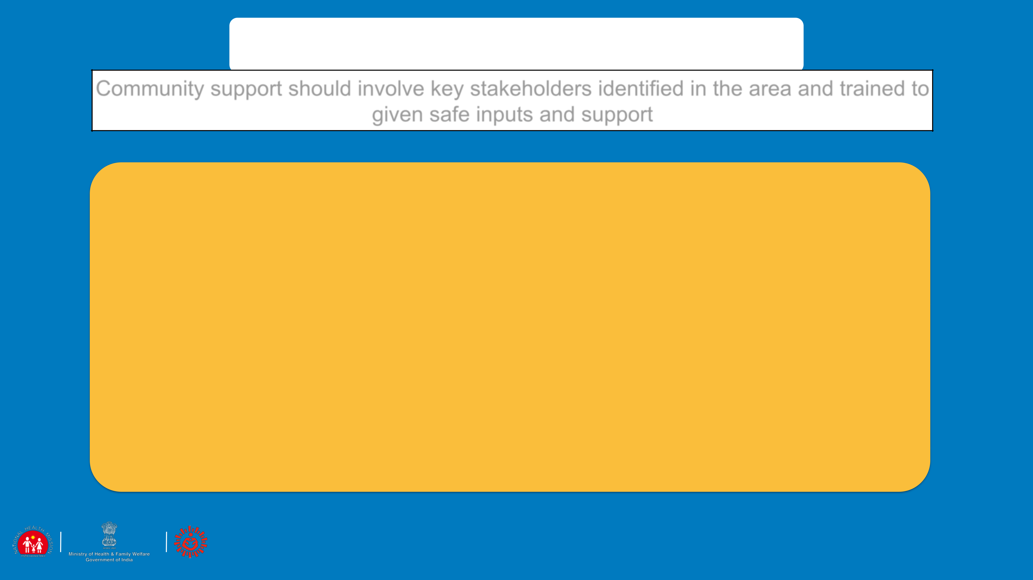

ACTIVATING SUPPORT

Community support should involve key stakeholders identified in the area and trained to given safe inputs and support

ADVISE COMMUNITY MEMBERS TO

* Volunteer for supporting the Community help-desk set up by local municipality
* Support the task of distributing masks in the community, ensuring that they are given to those who most require. Mask management to be taught while distribution
* Community representative to ensure that community cleaning and disinfection drive to be taken up regularly by the Municipal corporation
* Give information through local political and religious leaders involvement
* Give information out through common essential services like garbage vans, milk supply van etc.
* Free distribution of bleach/sodium hypochlorite solution and use of the disinfectant to be planned in the community

 42

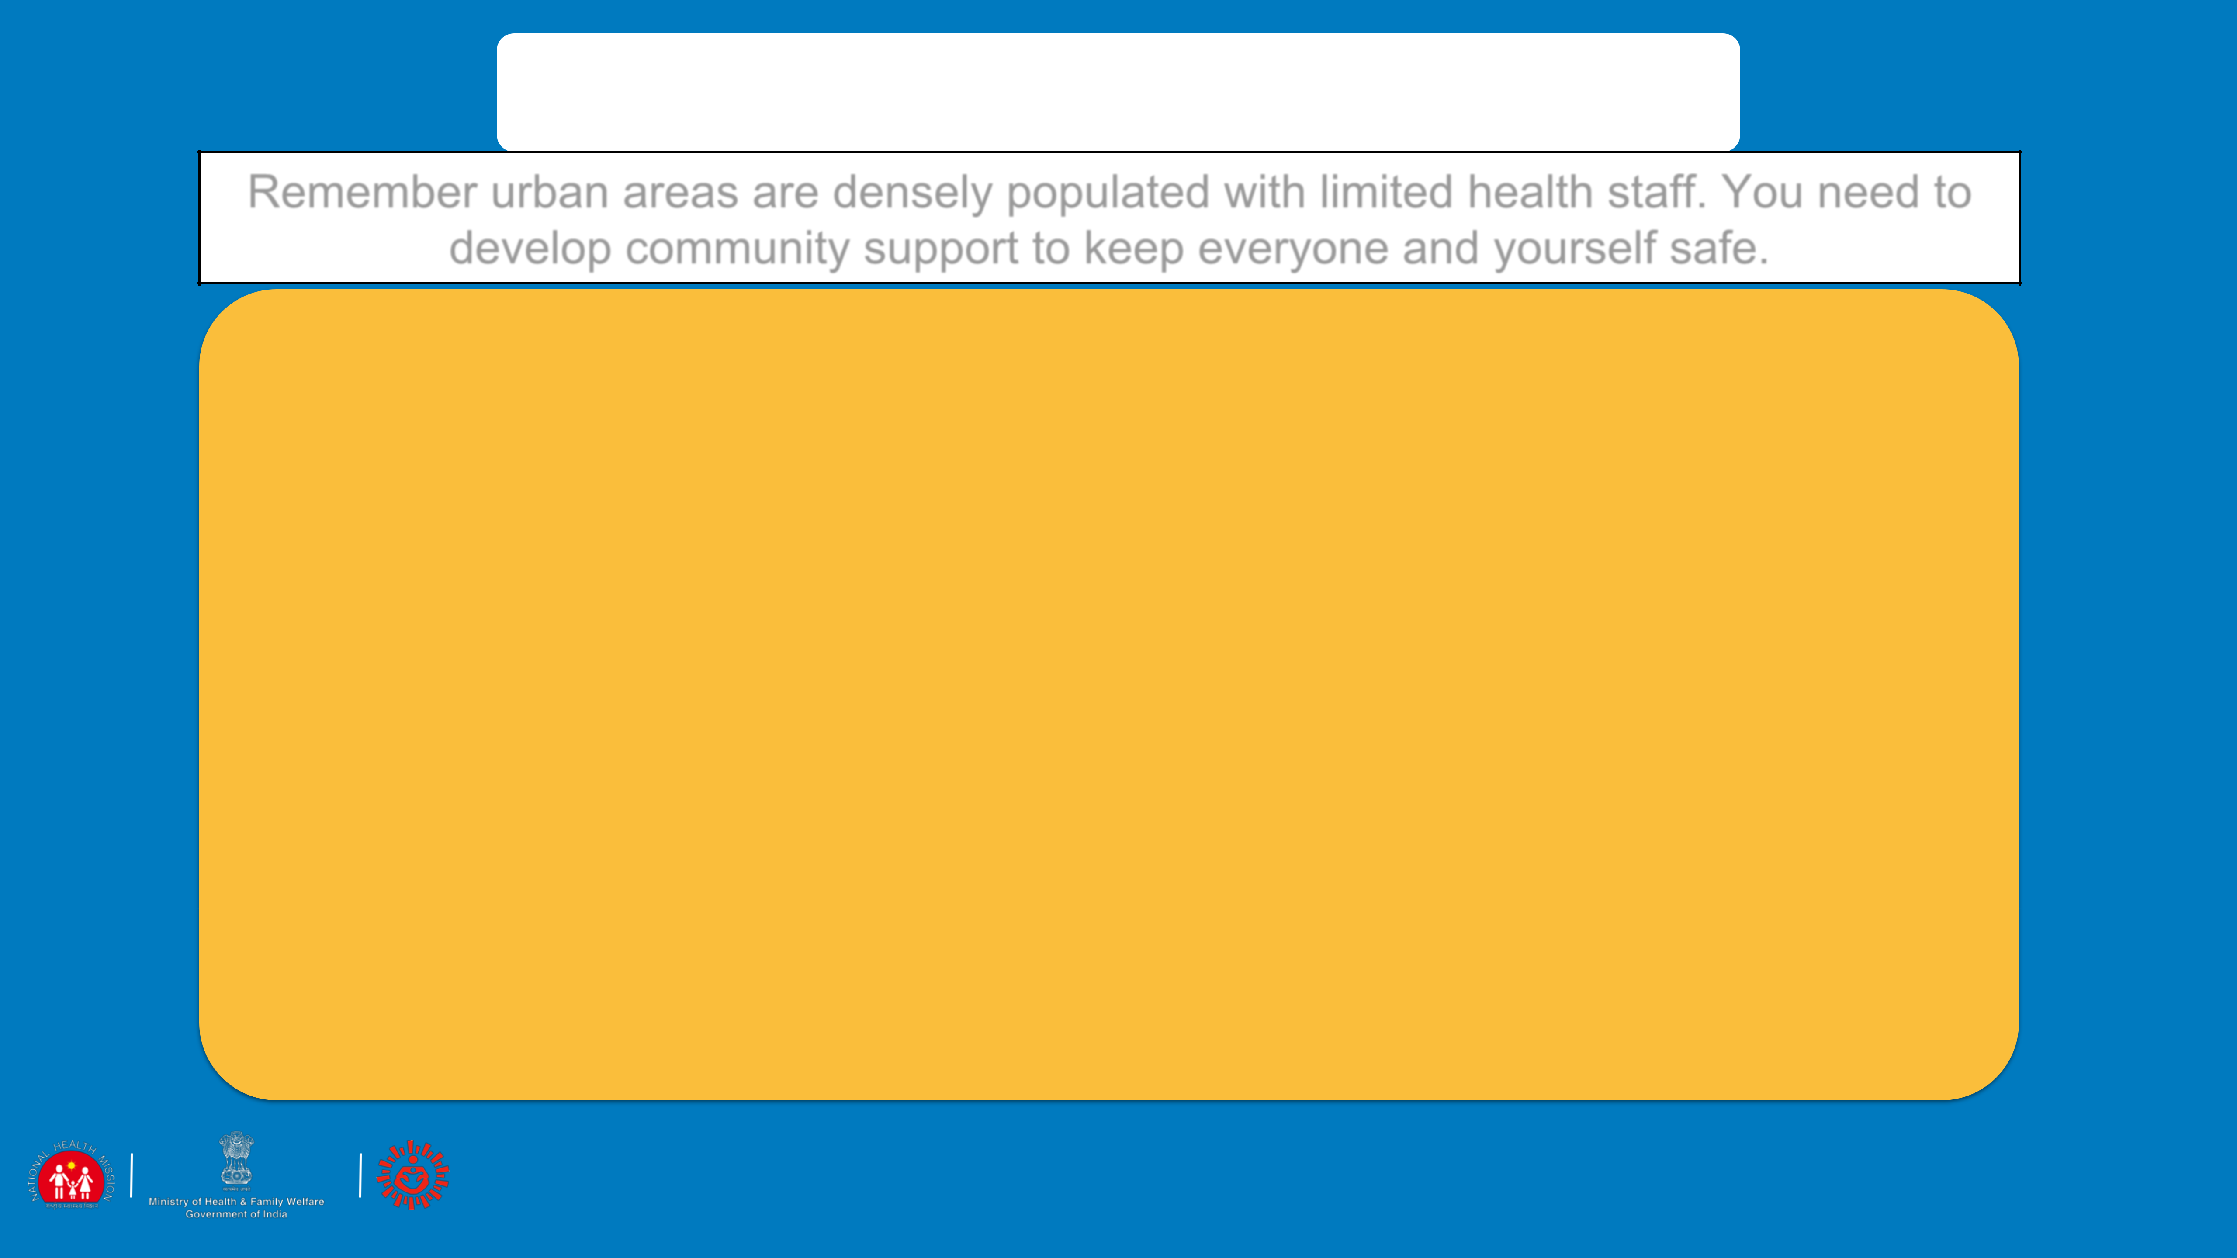

ACTIVATING SUPPORT

Remember urban areas are densely populated with limited health staff. You need to develop community support to keep everyone and yourself safe.

* Identify the high risk groups in the community and help them to isolate themselves to protect them from getting infected
* Be in touch with the government services to organise to get the mid-day meals delivered to the children’s homes.
* Get key influencers who can help you with vigilance and tracking people who may possibly be infected and report it for referral.
* Community level cadre to be trained to ensure compliance of protocols during lock down period
* Community level structure to be identified to transform into quarantine facilities

 43

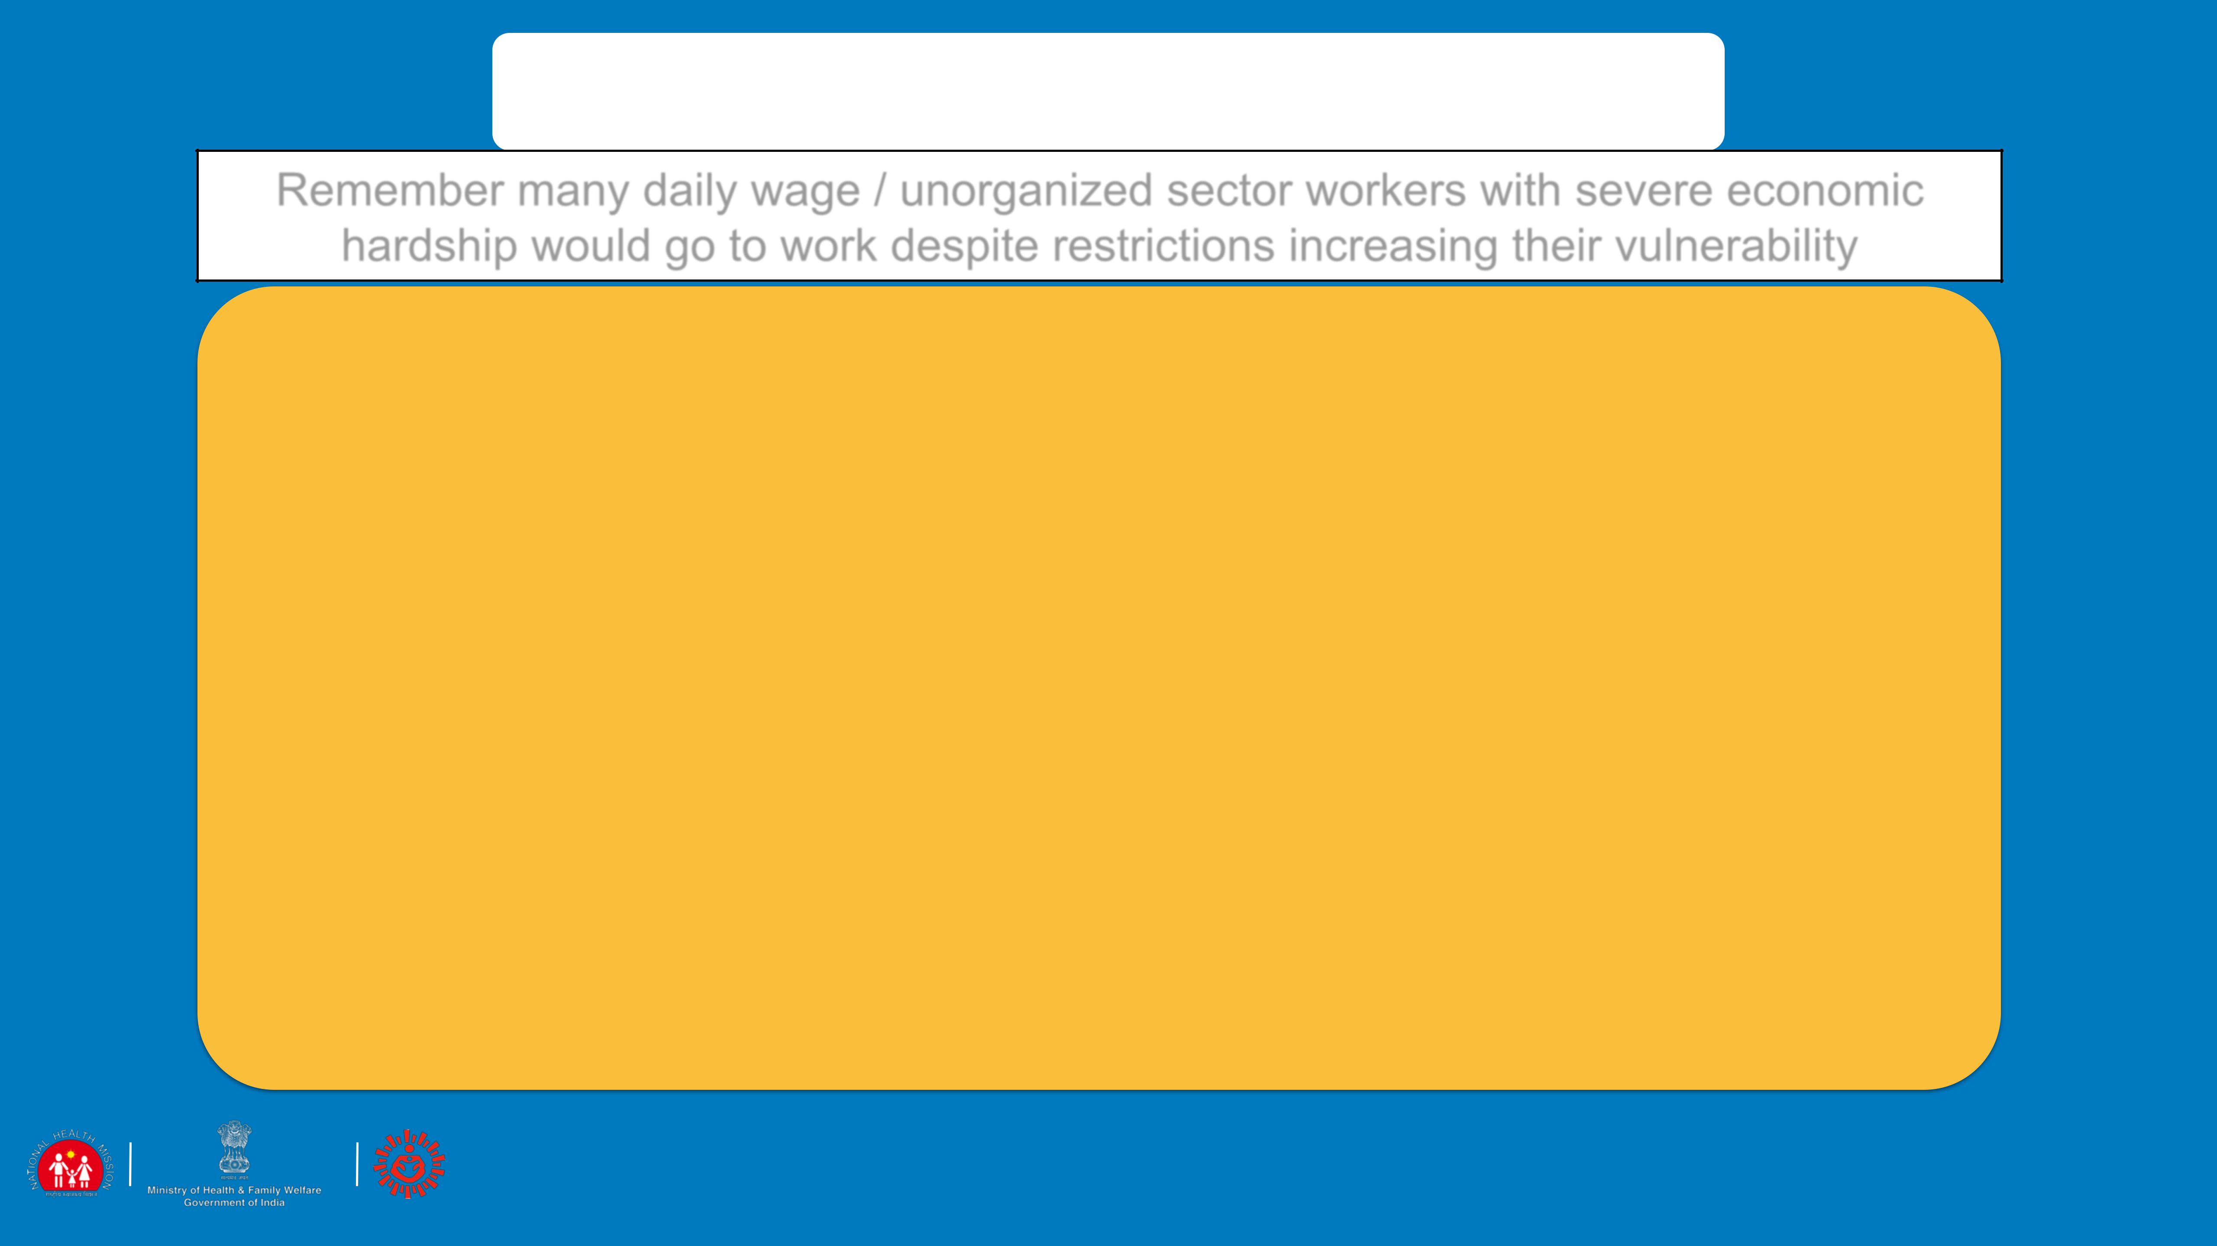

PRACTICING SAFE BEHAVIOURS

Remember many daily wage / unorganized sector workers with severe economic

hardship would go to work despite restrictions increasing their vulnerability

Reach out to specific group of people such as labourers, housemaids, shelter home migrants and daily wage workers and advise them to follow:

* Frequent handwashing with soap and water for 40 seconds especially after coming from outside, before eating food and after going to toilet.
* Change clothes and if possible wash oneself using soap after coming from outside. Avoid touching eyes, nose and mouth.
* Avoid spitting in open places and use only a wash basin or spittoon
* Maintain a distance of minimum 1 meter from others
* Contact community help-desk/ health facility if they develop fever, cough or difficulty in breathing or need any information

 44

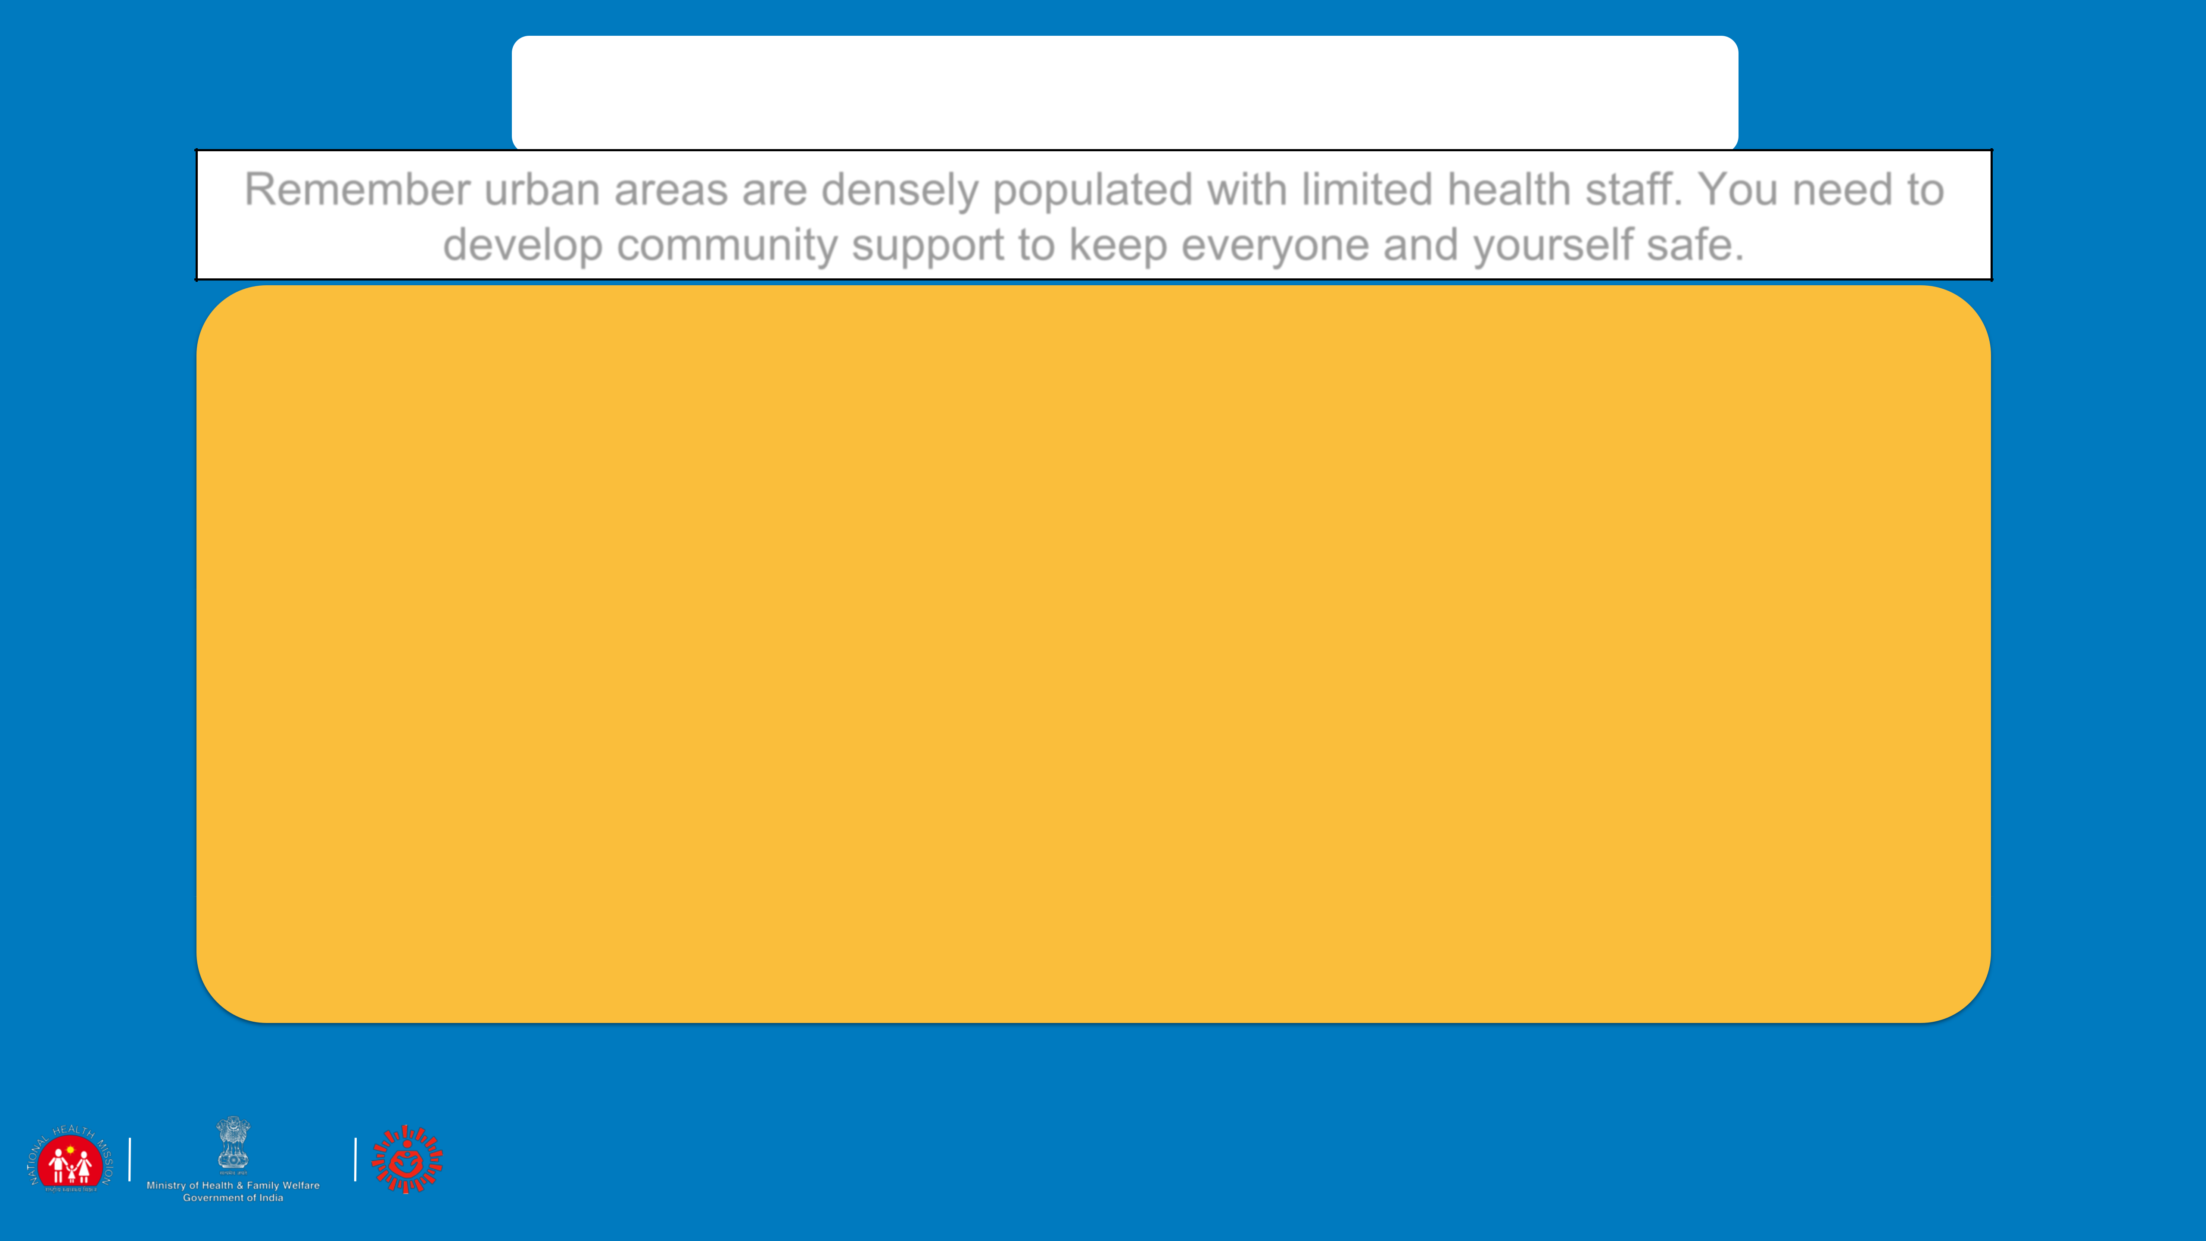

Stigma and Discrimination

Remember urban areas are densely populated with limited health staff. You need to develop community support to keep everyone and yourself safe.

Resident Welfare Associations

1. Many of the societies have stopped maids and other helpers from entering. While this is correct as this will keep people at home, the way of managing this distancing is stigmatizing
2. Words like “They will bring this disease to us” “The disease will spread because of them” etc are stigmatizing
3. Work with the local influencers and key decisionmakers of the area to sensitise people
4. Use the mass media clips to sensitise
5. Use government orders to show why housing societies should not discriminate against the working class like car cleaners, maids etc.

 45